

Downriver Community Clinic

Volunteer Handbook

Version 1.3

Date Issued: September 1, 2022
Latest Revision:September 8, 2024

Table of Contents
Table of Contents 1
Version Control 2
Safety and Security Protocol 3
General Clinic Processes 3
Internal Incident Reports 3
Front Desk 4
Sign In and Sign Out 4
Setup 4
Greeting Patients & Assembling Folders 5
New Patients 5
Patient Checkout 6
Closing Work 7
Sending Lab Results to Patients 7
Entering Appointments (Daysmart) 7
Entering Appointments (Practice Fusion) 8
Medical Assistants 8
Setup 8
Triage 9
Practice Fusion and Charting (For Medical Assistants) 11
Vitals 11
Confirm Allergies are Up-to-Date 12
Confirm Medications and Dosages are Up-to-Date 12
Instructions to Move a Medication to Historical 14
Chief Complaint Section 14
Summary Tab 15
General Introduction 16
Social History 17
Family Health History 18
Past Medical History 18
Allergies 19
Medications 19
Implantable Devices 19
Medical Scribe Checklist 20
Completing the chart during the patient encounter 20
Common Medical Abbreviations 26
Point of Care Testing 28
Hemoglobin A1C 28
How to enter Hemoglobin A1C into Practice Fusion 30
Retinal Exams 32
Setup 32
Steps to Capture the Image 34
Steps to Record Retinavue Exam in Practice Fusion 35
Cologuard 36
Adding Immunizations 36
EKG 37
GYN Nights 38
Room setup 38
Assisting Pap Smears 38
Henry Ford Wyandotte Hospital Lab Process 40
Specimens & Containers 40
Specimen Acceptability Criteria 40
Specimen Labeling Requirements 40
Requisition (Order) Create in PF with Vendor 41
Thin Prep 41
Cultures 42
Biopsy Containers (Endometrial, dermatology tissue) 42
Collection for Male Urethral Swab Specimens 43
Collection for Endocervical Swab Specimens 44
HFWH LAB Commonly Used TEST CODES 45
Miscellaneous 46
Urine Tests 46
Preparation 46
List of Commonly Requested Medical Equipment and Their Locations 46
FAQs 48

Version Control
Version | Date | Author(s) | Comments
0.1 | January 2022 | M. Yi | Handbook created. Front Desk Guide copied from instructions created by Reilly. Medical Assistant basic tasks and categories are outlined.
0.2 | February 2022 | M. Yi | Added scribing instructions and RetinaVue instructions
0.3 | March 2022 | M. Yi | Added GYN night, urinalysis, and retinal exam instructions. Ready for review.
0.4 | May 2022 | M. Yi | Implement changes based on feedback and review from N. Zacks, Dr. R. Steele, Dr. D. Angell, S. Schwartz
1.0 | September 2022 | M. Yi | First Official Release
1.1 | March 17, 2023 | M. Yi | Added information about internal incident reports
1.2 | July 2024 | J. Shaheen | Updated lab procedures due to change in lab vendor, included new processes in Practice Fusion, better defined the role of MA and Scribe.
1.3 | September 2024 | L. Shaheen | Updated scribe checklist, finalized updated lab procedures, and reorganized manual to emulate real-life clinic process.
Version control process: versions are labeled as X.Y. Prior to the first official release, any changes made to this document requires incrementing “Y” by 1. The first official release is version 1.0. After the first official release, every time a change (add new instructions, update outdated instructions, adding pictures, changing formatting, etc.) is made to this document, increment X by 1. If a change involves grammar or other non-content related changes, X remains the same, and Y is incremented by 1.

Safety & Security Procedure (9.2024)

NOTE:
All doors into the Clinic will be kept locked at all times and only unlocked to let a patient in.

3 Panic buttons are located at the front desk. (know the locations)
As a tenant of Henry Ford Health and following their protocols for Safety and Security, Downriver Community Clinic intends to provide a safe and non-violent environment for its employees, patients, guests, and visitors free of threats, harassment, intimidation, physical and verbal abuse, and coercion. This means that all violence and threats of violence are unacceptable behavior.

Above all, keep yourself safe, do not confront or try to manage unless you are trained to do so. The following are the steps to be taken when encountering a safety or security issue.

1. Police situation – if you observe or experience a threat, bring it to the attention of the office admin and/or attending physician. Use the panic button and call the hospital operator at 734.246.6000 and briefly state the issue (send hospital police, the threat from a person, an altercation happening, a person with a weapon, etc.)

2. Fire – pull fire alarms and get out of the building (know where extinguishers and alarms are located)

3. EMS - Patient or volunteer in distress, Call 911

General Clinic Processes

Internal Incident Reports
Internal Incident Reports is a form available for volunteers to complete whenever volunteers witness something of concern in the clinic. (Example event: mistakes when completing specimen forms.) When this report is completed and submitted to the Clinic manager, the incident may be brought to the Quality Assurance Committee and Board of Directors. Upon evaluation of the incident, new processes, policies, and/or additional training may be implemented to prevent similar events from occurring again.
The forms are available at the following locations:
- Clinic Manager’s Office
- Front desk mobile cart
- Galaxy Digital volunteer platform
- The Appendix section of this handbook

We continuously strive to foster an open and supportive environment, where individuals feel comfortable speaking up. However, the option of anonymous reporting will be available as well. To do so, simply submit a hard copy of the form.

Sign In and Sign Out

- At the beginning of the month, sign up for available clinic dates in Galaxy Digital.
  - To sign up, click this link https://wyandotteclinic.galaxydigital.com/need/
  - Select the position that you will be volunteering as (Scribe, Medical Assistant, etc.)
  - For the dates you would like to volunteer, click “Respond Individually”
  - To confirm the dates, click “Submit opportunity response”

Front Desk Setup
- Login Computer
  - Bring your own laptop or use a clinic laptop from Admin office. If you use your own laptop, change your wifi in settings to DownriverCC. Password: WyClinic
and check that your PF settings are 99213 for Encounter type.
  - Open up Daysmart Scheduling, Practice Fusion (PF)
- Place red folder organizer on counter by the check-in window
- Place donation box on checkout counter
- Make sure all appointments from Daysmart are in PF
- Set out patient folders, schedule, and necessary cart folders on the counter
  - Consent to contact
  - New Patient Forms
  - Flu Vaccine Information Sheet
  - Dr. Wolf Exam Sheets (GYN nights)
  - Lab and/or Imaging Instructions
  - Patient satisfaction surveys (given at the end of the visit)

Greeting Patients & Assembling Folders
- Greet patient and ask if there is any change in address or phone number
- Check driver’s license to make sure it is not expired
  - If so, ask to take a new copy
- Ask patient for preferred pharmacy and update Practice Fusion accordingly
  - To add/update pharmacy, go to patient’s chart → “Profile” → Prescriptions Section
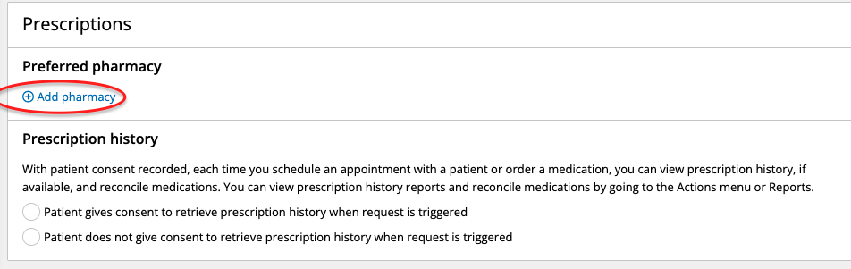
- Give patient COVID screening paper for them to fill it out
  - Once patient returns this form to you (or if you verbally ask the patient at the check-in window), enter their responses into Practice Fusion using the COVID-19 screening template under “Subjective” section
  - If patient says “yes” to any of the questions (except the vaccination status question), consult with doctor if the patient should still be seen
- Write date on front of patient folder in PENCIL
- Write patient name and date on exam sheet in PENCIL and insert into folder
  - In the future, we may ask front desk personnel to paperclip this sheet to the front of the folder. When this process is implemented, the steps here will be updated
- Insert flu vaccine info and consent form into folder
- Dr. Wolf (GYN night ONLY): write name of patient and date on his exam sheets
- Place folder in red organizer (first patient to be seen is at the front of the organizer)
- Change status of patient in PF from “pending” to “in lobby”
- Change status of patient in AP from “scheduled” (yellow) to “arrived” (purple)

New Patients
- Ask to copy driver’s license and pay stub
- Give patient all 3 pages of new patient forms and Consent to Contact form
- Grab blank folder from bottom of cart and write patient name on side and bottom in PENCIL
- Tape copy of license to the inner left pocket on upper left side
- Review that patient info is correct on their PF profile once paperwork is returned
  - Name spelling
  - Email
  - Address
  - DOB
  - Gender
  - How they want to be contacted
  - Phone number
  - Race/Ethnicity
  - Preferred pharmacy (if given)
- If mailing address is different from address on license, make sure to write the correct mailing address in PENCIL on pocket next to the taped copy of license

Patient Checkout
- Ask patient if they were given any prescriptions or lab work
  - Lab order should be printed from PF and given to the patient if the patient was not given the form already by medical staff.
    - To print this form, click “print” in the bottom right corner of the tab at the end of the lab order process.
    - At the top of the form, you will see a printer icon. Click this icon, and select the printer you wish to print from
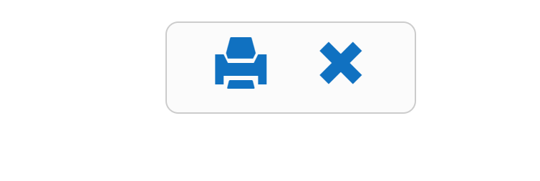

  - If order is not in practice fusion, get assistance from MA or scribe.
  - If any lab or imaging orders have been made, give patient lab work instructions form
  - If a medication has been prescribed, confirm it will be sent electronically via preferred pharmacy. Confirm pharmacy with patient and add this information to the patient’s chart. To add/update pharmacy, go to patient’s chart → “Profile” → Prescriptions Section
- Give patient the Patient Satisfaction Survey
- Ask patient if they need to make any follow-up appointments
  - See “Entering Appointments: Appointment-Plus for instructions”
- Encourage patient to set up their patient portal (Patient Fusion) to view their visits. Patients will receive an email with instructions to set up their portal. Tell patient to contact us if they do not receive an email.

Closing Work
- Make sure all patient demographic information is entered in PF
- File all patient folders that are finished
- Exit out of all tabs on the computer
- Log off computer - shut down if using clinic laptop
- Lock ALL doors
  - Double doors in front of building
  - Back exit door
  - Lobby door
- Turn off TV and lights in lobby
- Make sure all folders, trays, donation box, and anything taken off the cart is returned
- Place both cart with folders and coffee cart back in office

Sending Lab Results to Patients
- Confirm with the patient how they would like lab results delivered.
- If electronic, confirm email or other preferred method of communication (should be on contact form.)
- If US Mail:
  - Take copies of all lab result sheets as well as sheet filled out by doctor giving follow-up instructions (make sure printer is set to “2-sided → 2-sided” so that all sheets will be copied front and back)
  - Switch cover letter (sheet filled out by doctor with follow-up instructions) so that the original results have the copy of the cover letter and the copied results have the original cover letter
  - Address envelope to patient and fill it out based on patient’s mailing address
  - Place COPIED results with ORIGINAL cover letter into envelope
  - Seal and place in outgoing mailbox located on the wall around the corner from the “employee only” bathroom

Entering Appointments (Daysmart)
- Click on date in calendar (left hand side of screen)
- Click “+” under doctor’s name for desired time
- Type name and click enter → click patient name from dropdown box
- Click “Next” at the bottom right of the screen
- Change “Status” at top of screen from “Patient Confirmed” to “Scheduled”
- Change “Service” at left hand side of screen to “___ - Returning Patient”
- In “Health Issue” write what they will be in for; for example:
  - Follow up on lab results
  - Rx Refill
  - Evaluate progress on issues discussed on 00/00/0000
- Click “Next” at the bottom right of the screen
- Click “Finalized Appointment”
- Give patients an appointment reminder card located in the green pencil pouch in cart

Entering Appointments (Practice Fusion)
- Click “Schedule” on far left side of screen
- Change the screen from “Appointments” to “Day” at top of screen
- Click the little calendar picture button in the top-mid screen & select the date
- Select the doctor for that date in the shaded blue box to the left
  - Deselect any other doctor’s names
  - If the doctor has 2 names listed, select the bottom of the 2 names (if the wrong “inactive” name is selected it’ll let you know. Just select the other option)
  - For ER nights, use “Adams, Nicole”
- Click on patient’s name in Daysmart & select corresponding time in PF
- Enter patient names, appointment types, and chief complaint accordingly to Daysmart in PF
- Change the time/duration if necessary
- Click “save”

Medical Assistants

Setup
- Turn on lights in the triage room (room #1) and rooms #2 through #4 and check everything is in order and cleaned
  - If it’s Dr. Wolf’s night, always turn on lights in rooms #5 and #6 (the large procedure room)
  - On some nights, the attending may request fewer rooms be opened up or more rooms be opened up, depending on how many residents/med students they have, so check with them on their preferences at the start of the clinic
- Take out the Hemoglobin A1C machine, plug it in and turn it on (See Hemoglobin A1C setup for more instructions)
- Take out the thermometer and pulse oximeter for temperature check and SpO₂

Triage
Note: If there are more patients than rooms available, triage the patients and ask them to sit in the lobby until they are called back when a room opens up
- Open the patient’s encounter for the current clinic session in practice fusion (Do not make a new encounter).
- Ensure the encounter type is 99213.
- Call for the patient and obtain their temperature at the door (before they come into the office space!) Record temperature in chart.
  - If temperature is 100 F or higher, ask them if they have experienced COVID symptoms and consult with the attending to see if the patient should still be seen.
4.Ask patient to go into the triage room (exam room #1)
- Introduce yourself
- Record blood pressure and heart rate
- Make sure the cuff is of the appropriate size, placed correctly and snugly (don’t put it on too loosely. The patient will tell you if it’s too tight)
- Make sure the artery line lines up with the brachial artery (see picture)

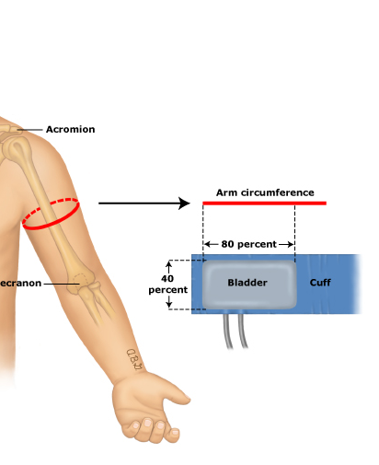
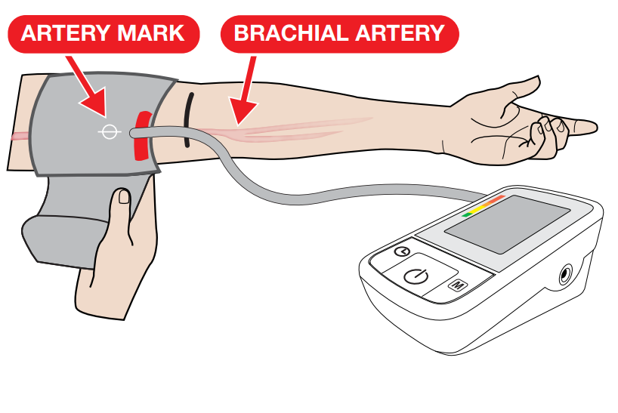
- Have the patient place their arm at heart level (have them rest their arm on the handle of the BP machine)
- ** If systolic is over 140 or diastolic is over 90, leave the room and allow the patient to sit quietly alone for 15 minutes and retake the blood pressure. Retake the BP!!
- Ask patient for their allergies → Note severity, type of reaction, and onset date if possible
- Ask patient for current medications, dosage, and frequency and if they need refills
  - Move any inactive medications to historical, and do not delete the medication from the chart!
  - Confirm preferred pharmacy with patient. If not in practice fusion (or incorrect) enter the pharmacy in the “Profile” tab under “Preferred Pharmacy”
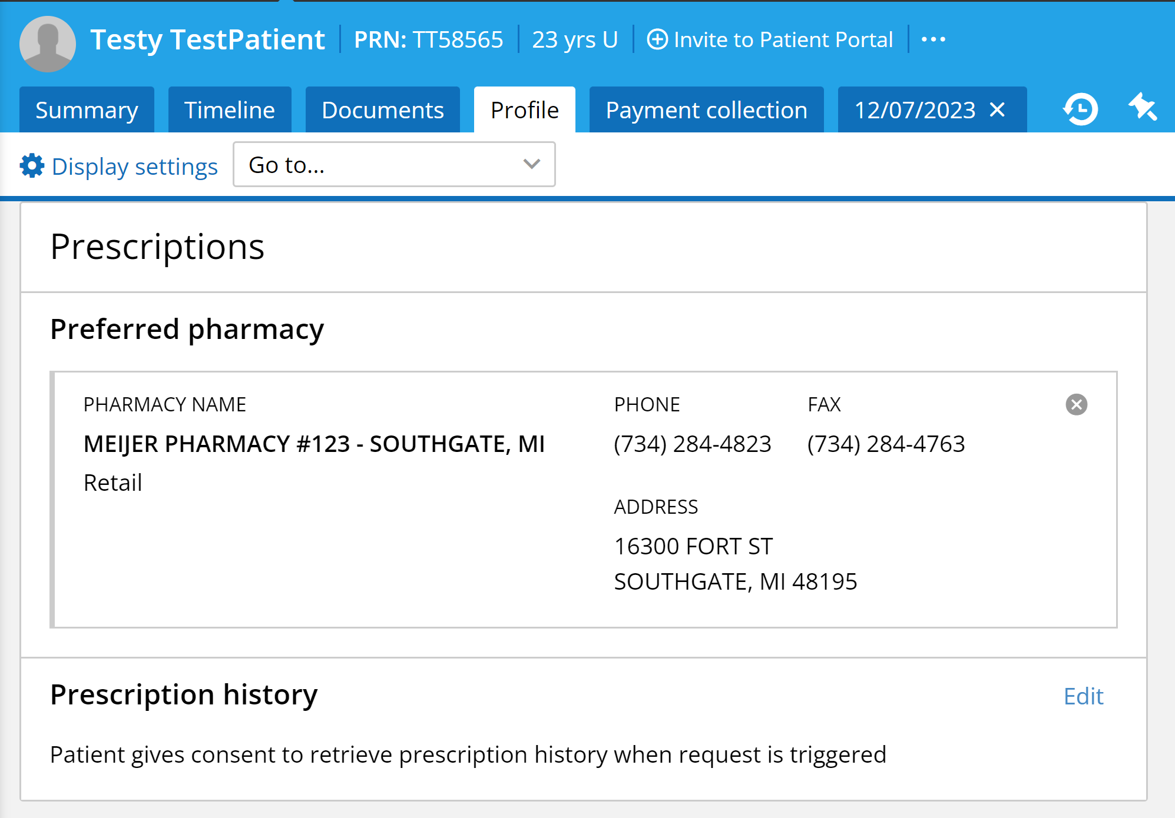

  - Ensure that after current medications have been updated, the box titled “Was medication reconciliation completed?” is set to “Yes, reconciliation performed”
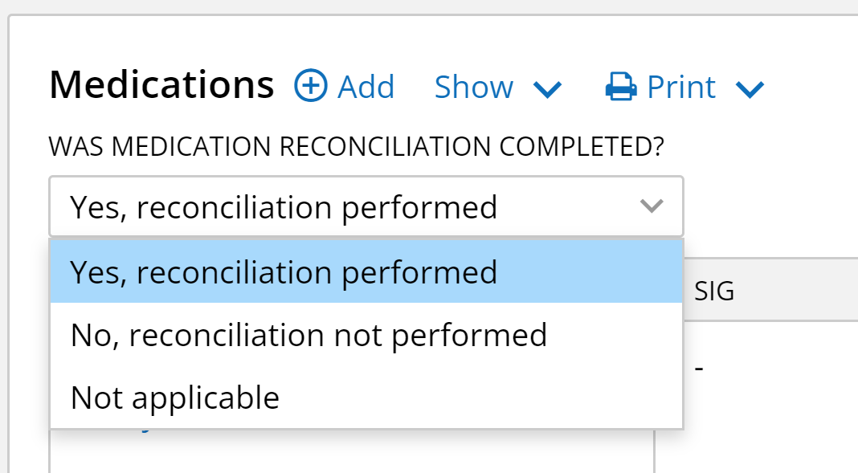

  - Also ensure that in the “Quality of Care” section at the bottom of the encounter, the box titled “Documentation of current medications” is checked. This is important because it will allow us to do data analysis for medications.
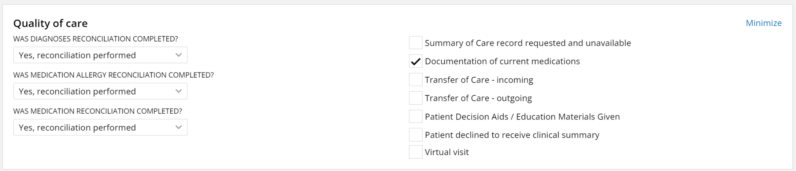

- Ask the patient for the last menstrual cycle (record in vitals column), pap smear, and mammogram (record in chief complaint).
  - A MUST on OB nights. For Dr. Wolf, record this information on his exam sheets.
- Within the Summary Tab, record/verify past medical history, family history, and social history and record any new events (refer to Summary Tab section on page 11 for more details).
  - If there are a lot of patients waiting to be triaged, ask these questions after you bring the patients to a room, in order to free up the triage room for the next patient
  - Use your best judgment on timing and how to coordinate patients!
  - If you don’t have time to get the information from the patient, give them a paper version of the Summary Tab to complete while waiting.
- Ask patient for the reasons for their visit (also known as their chief complaint)
- Bring patient to an open room (if no availability, ask them to sit in the lobby)
- Update Practice Fusion to reflect the patient’s room # or select “Lobby” if they’re in the lobby
- Discuss with the Physician their preference of how to let them know that a patient is ready, and in which order they should be seen.

Practice Fusion and Charting (For Medical Assistants)
- Please do NOT open a new encounter note. When the patient checks in, the front desk staff will open an encounter note, and you will use this note to chart!
- Note: All accounts should have the default encounter type set to 99213 (Go to settings, choose encounter type, and search and select 99213).
- Vitals
  - Create a new column of vitals for the patients -- be sure to save! (the save button will appear after creating a new column). Record vitals as described in the Vitals section of the handbook
  - Note: BP and A1c should autofill into the flowsheet
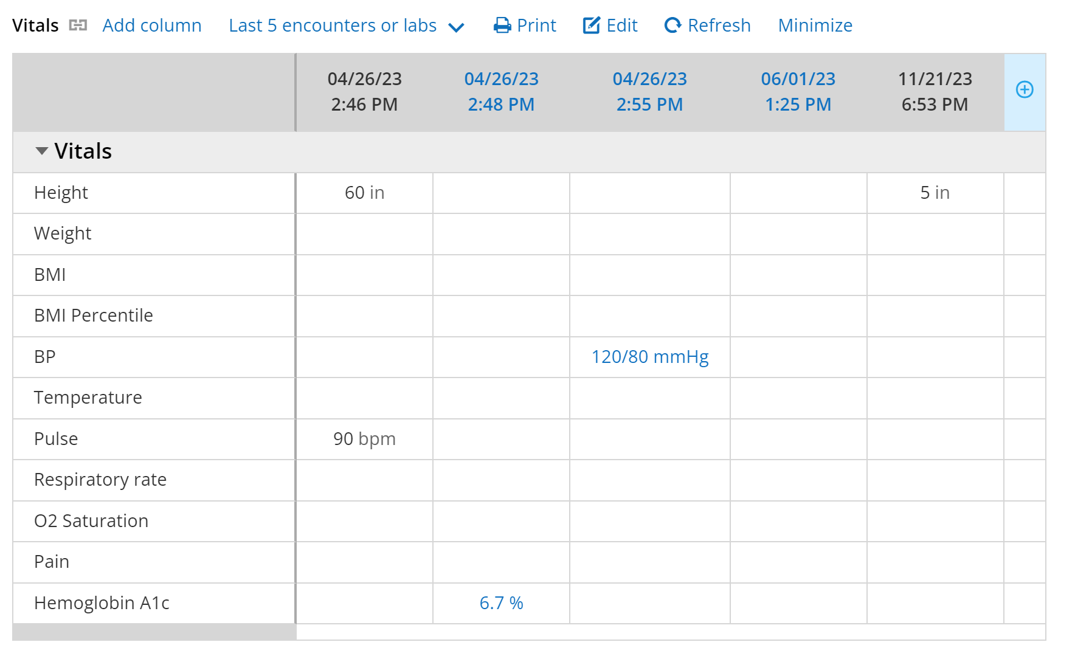

- Confirm allergies are up-to-date
Directions to add an allergy:
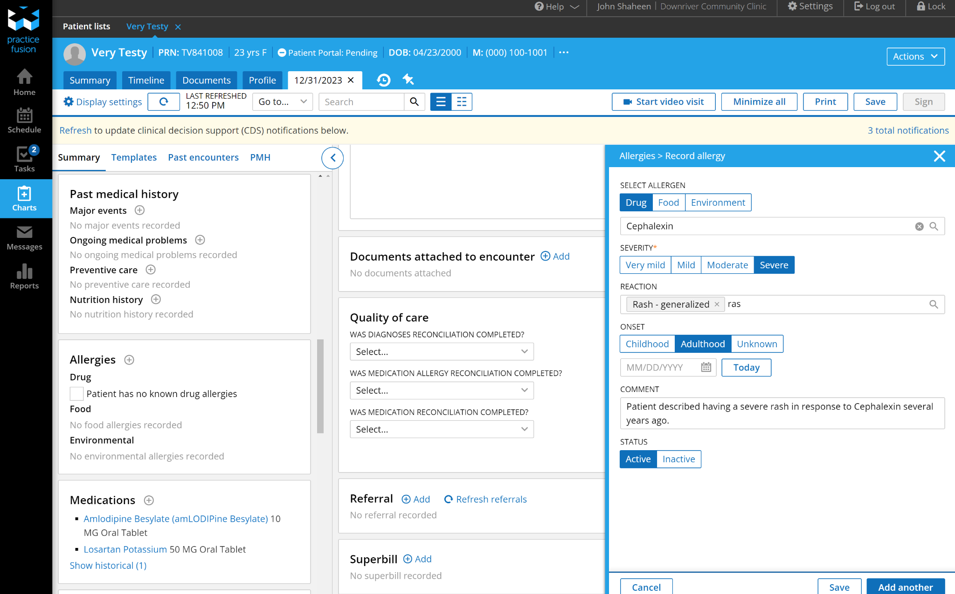

b.
c.

d.

a.
- Allergies can be found in the summary sidebar, or the patient Summary Tab. To add an allergy click the “+” button labeled “a.” in the above diagram.
e.
- Pressing the “+” button will open a tab (labeled “b.” on the diagram).
- Select the kind of allergen (either drug, food, or environment), and type the specific allergen in the box labeled “c.” on the diagram
- Select the severity of the allergen based on the patient description (consult with the physician if unsure how to categorize) and type the specific reaction that the patient had in the box labeled “d.”
- Select the onset of the allergy (when the patient’s first reaction occurred) and type anything the patient describes about the reaction in the Comment box labeled “e.” on the diagram.
- Unless the patient is confirmed to no longer have the allergy, ensure the selected status is “active”
- Press “save” at the bottom of the tab.

3. Confirm medications and dosages are up-to-date
- Instructions to Add a Medication:
- To add a medication, click the “+ Add” button at the top of the medications tab in the encounter. This can also be accessed in the patient’s Summary Tab. A new tab will open. Type the name of the medication in the box that appears, as seen below, and select the correct dosage.
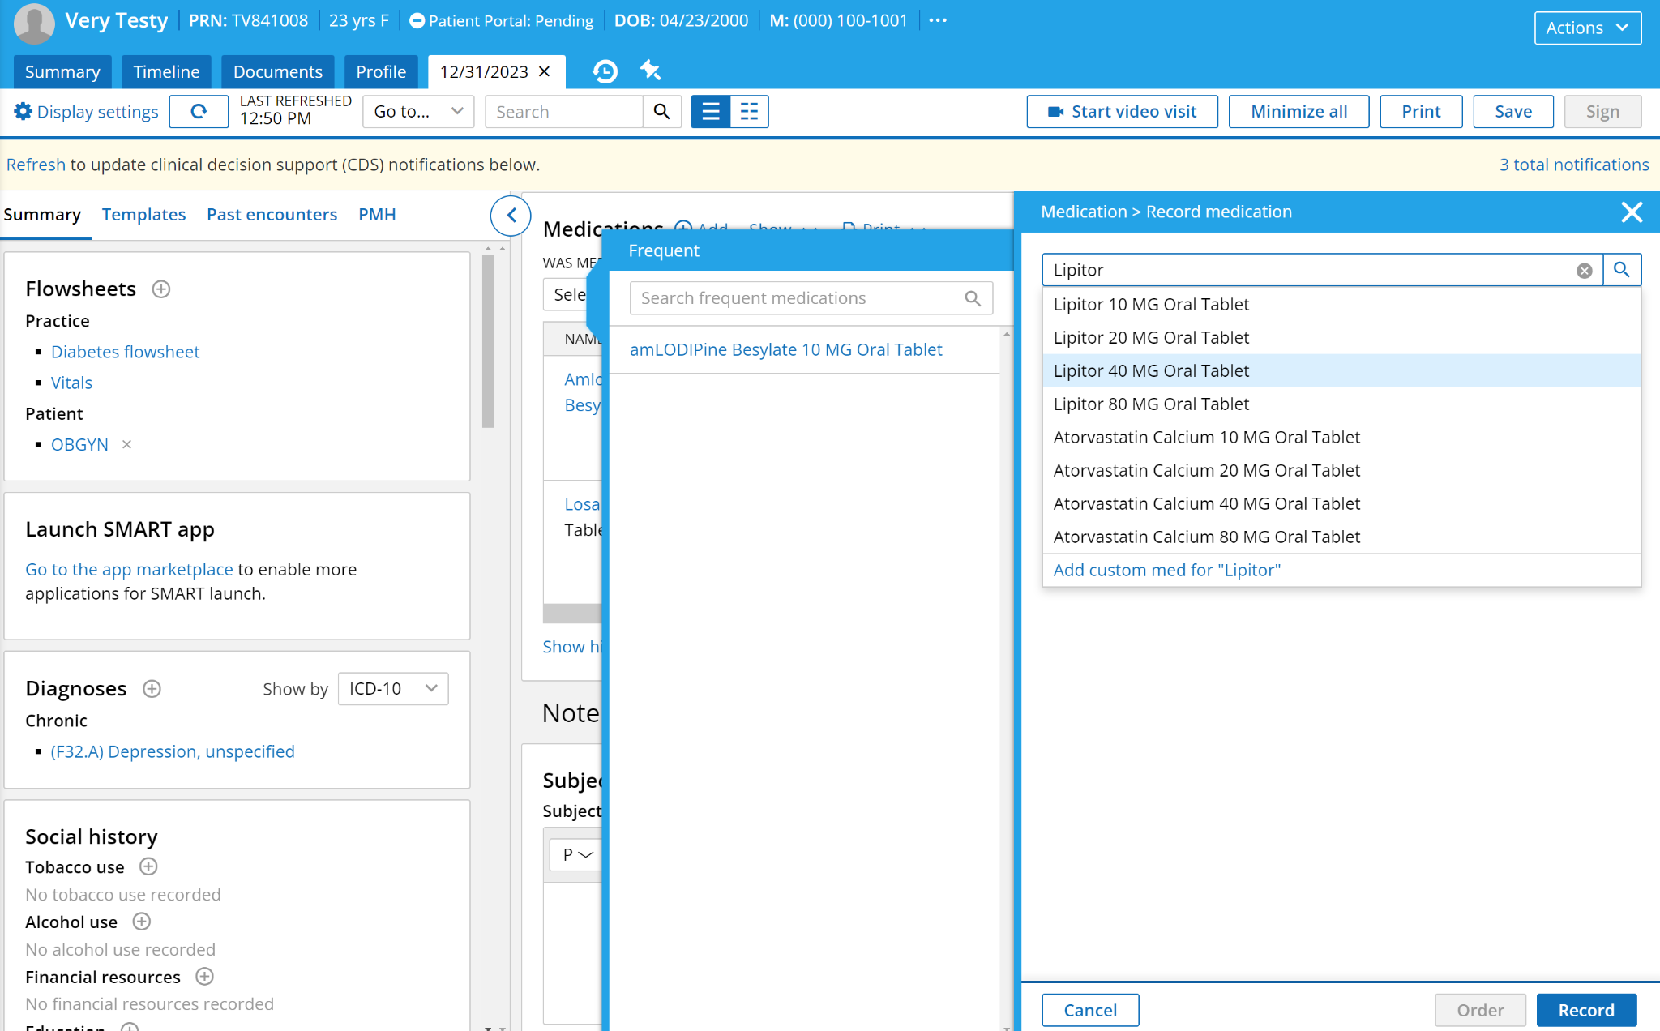
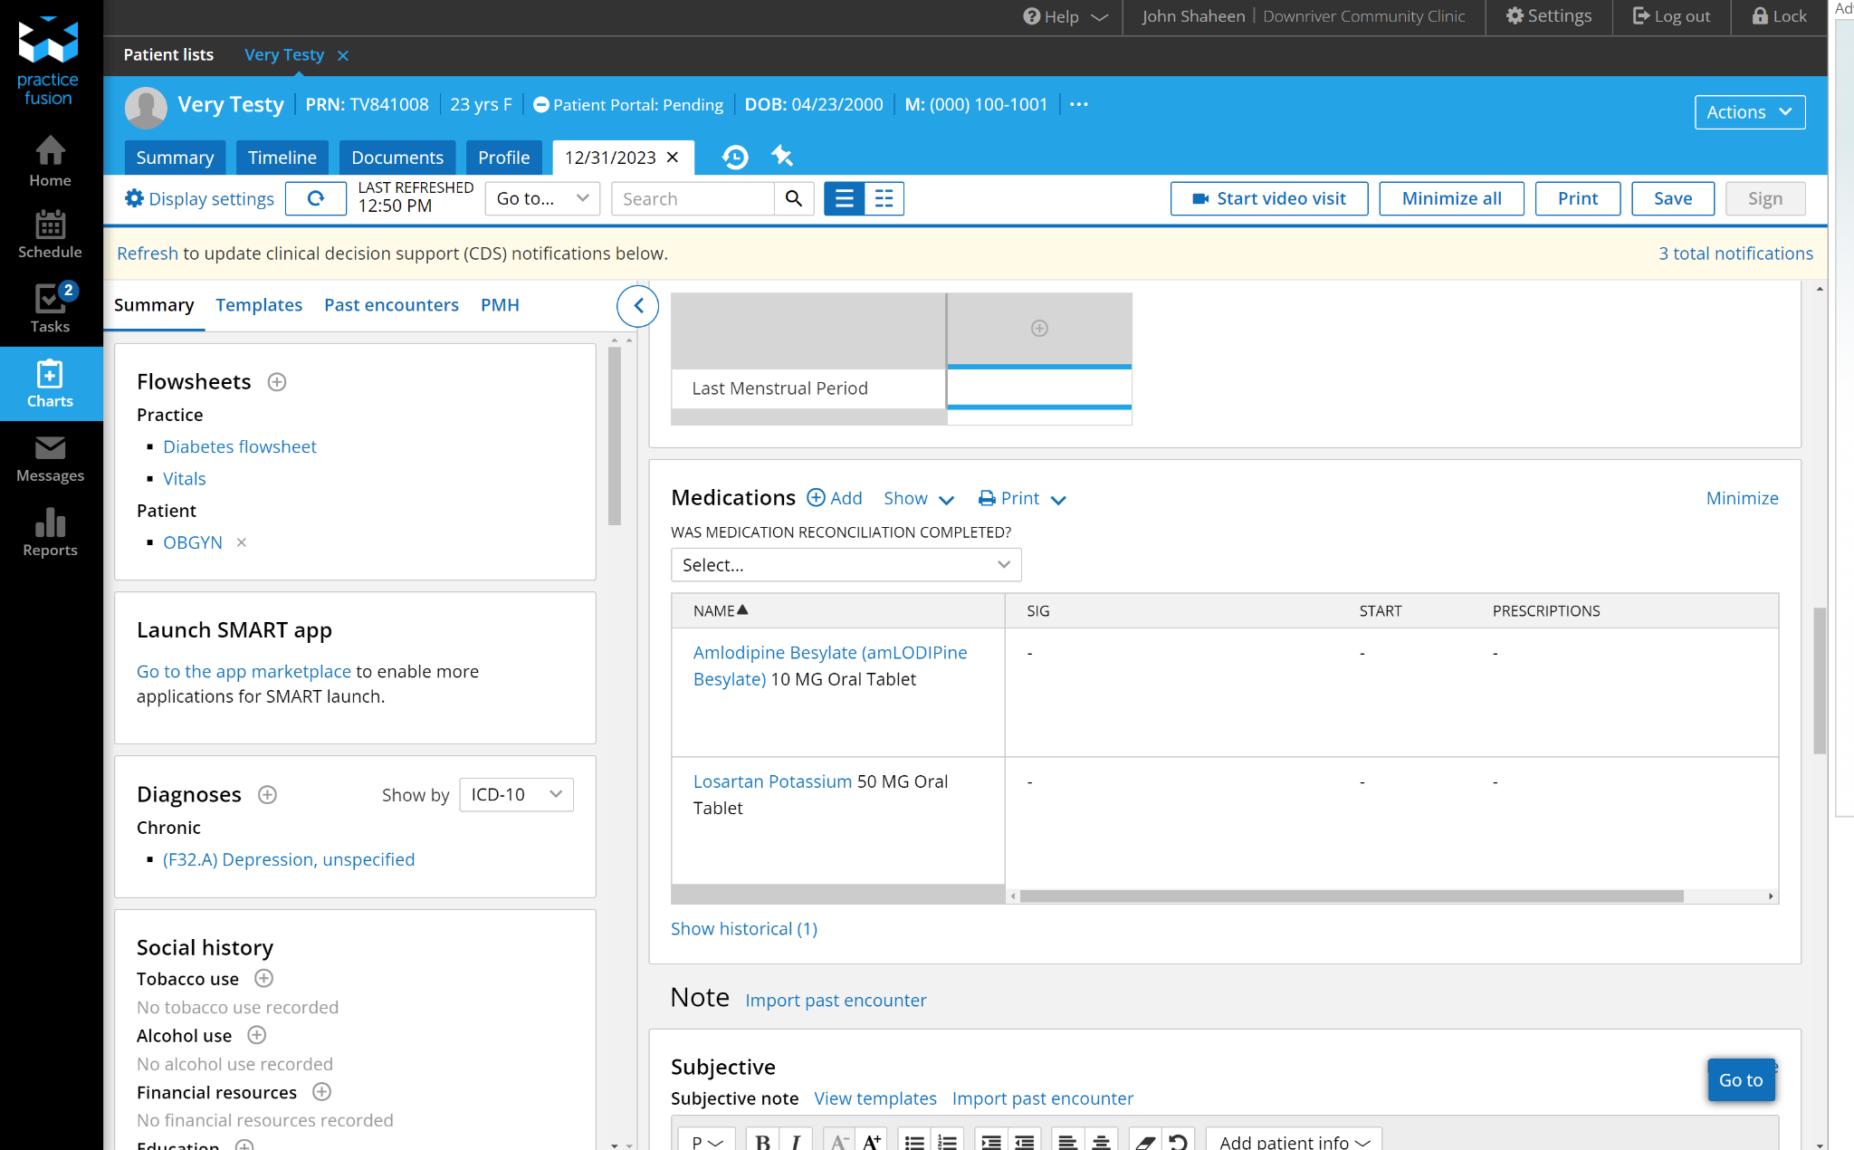

- After selecting the medication, select the method that the medication is taken as described by the patient in the box labeled “a.” on the diagram below.

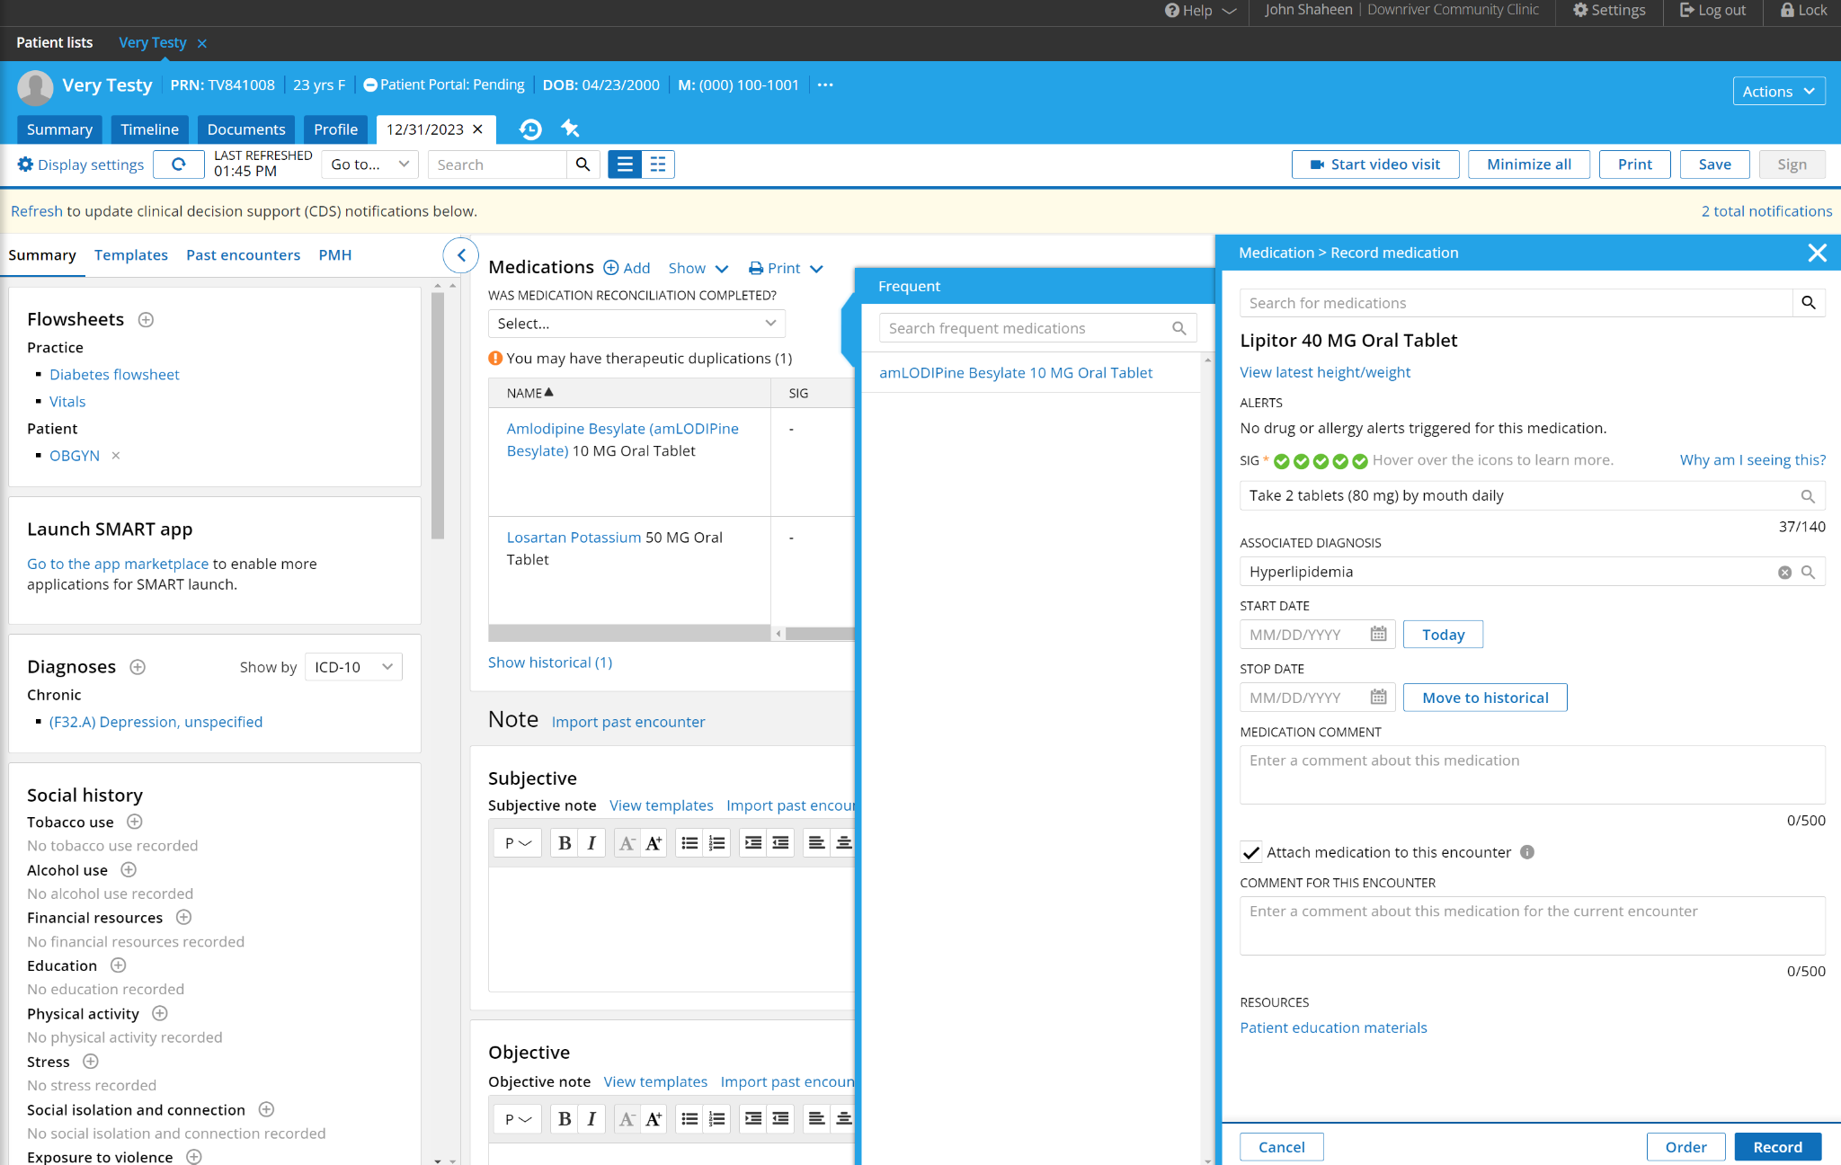
a.
b.

- In the Associated Diagnosis box labeled “b.” on the diagram, select the diagnosis associated with the medication. If unsure, consult the physician.
- If the patient knows the date that they started the medication, include it in the box labeled “start date.” If not, feel free to put an estimate in the “Medication Comment” box.
- Leave the “stop date” blank if the patient is still taking the medication
- Ensure that the checkbox is checked to attach the medication to this encounter
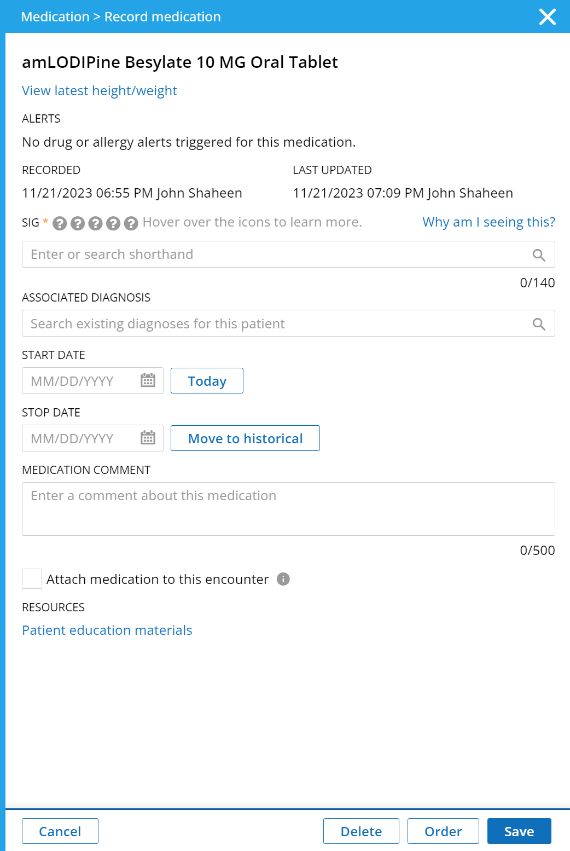
- Click “Record” at the bottom right of the tab to save the medication.

- Instructions to Move a Medication to Historical

- If a patient no longer takes a medication, click move to historical to remove it from their current medications. It will be stored in the historical medications tab below the current medications. It can be accessed by clicking “show historical.” Then click “save.”

- If a medication was added in error, and was never taken by the patient, click the “Delete” button.

- After confirming all medications are up to date, select “Yes, Reconciliation Performed” in the box at the top of the Medications tab.
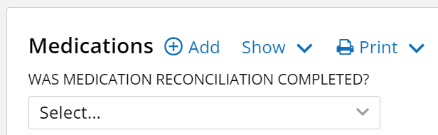
4. Chief Complaint Section
  - Anything the patient tells you for the reason of their visit

Other Components of the medical note include the following items to be completed by the scribe and physician:

SOAP Note Section (Subjective, Objective, Assessment, Plan)
- This section should be completed by the doctor or scribe (ONLY AN FYI FOR MEDICAL ASSISTANTS)
- Subjective:
    - Anything the patient and doctor discuss.
  - Objective: Physical Exam and Findings
    - Anything the med student/resident/attending has assessed
    - Includes heart and lung sounds, coloration, edema, etc.
  - Assessment: Diagnosis
    - What the med student/resident/attending has determined to be the diagnosis
    - Make sure you update the list of diagnoses (ICD-10 codes) for the patient (attach to current encounter)!
  - Plan: Diagnostic Tests Ordered, Prescriptions Ordered, Plan for Follow Up
    - If any medications are prescribed, the name, dosage, amount dispensed, and number refills must be documented, along with date of refill/prescription.

Summary Tab
**If you are not using the universal Practice Fusion login, you MUST update your Practice Fusion settings as below:
1) Go to “display settings” in upper left corner of a patient’s chart
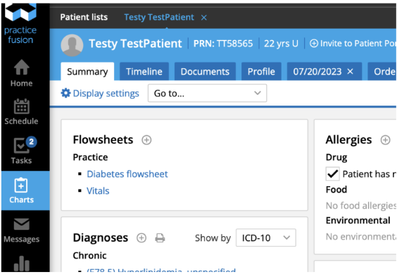
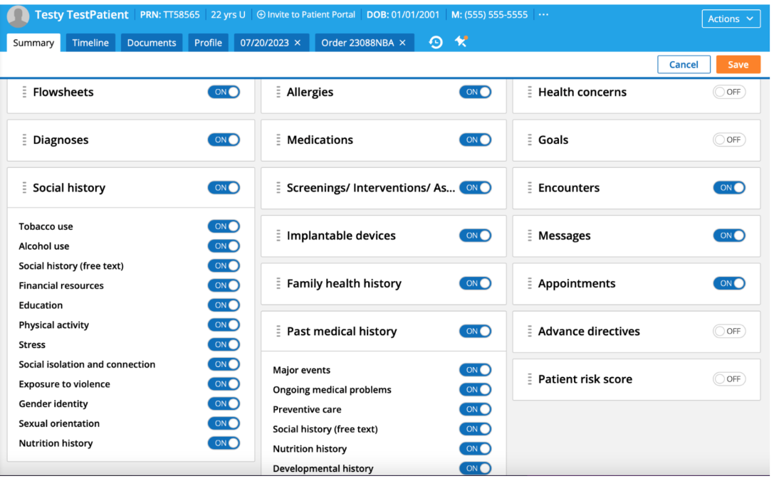
2) Turn on/off settings to match the settings below
3) Select “save” - once saved for initial patient, you never need to update again and it will reflect these settings for all patients moving forward
4) You are now ready to tackle the Summary Tab!
General Introduction:
- Goal is to complete the Summary Tab for the patient in its entirety. However, if time is limited, be sure to complete MEDICATIONS AND ALLERGIES.
- The Summary Tab should be completed once the patient has been triaged and placed in the exam room. This frees up the triage room and ensures the doctor is not held up from seeing the patient.
- The Summary Tab can also be completed at the time of discharge. Invite the patient into an empty office and complete.
Items that MUST be completed prior to physician seeing patient: -Medications (medication list must ALWAYS be reconciled prior to physician seeing patient, even if patient is not taking any medications)
-Allergies
Items to complete before check out:
-This information only needs to be completed/updated once a year
-Social History
-Family Health History
-Past Medical History
-Implantable Devices
● in the free text area at bottom of each section “date completed/updated: xx/xx/xx” 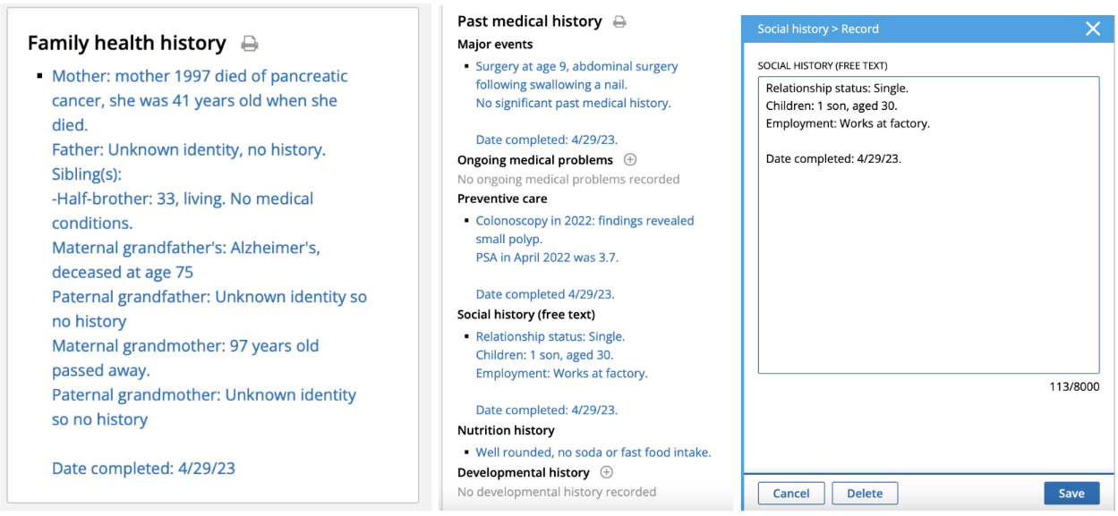To note:
-If unsure of date(s), use best approximate guess of the year and log as 01/01/year

Social History
-These can be sensitive questions to ask and for the patient to answer. You may want to say the following before asking them:
“I have some sensitive questions to ask you regarding your medical history. They are optional. They are important as they will assist the doctor in making medical recommendations/decisions specific to your individual medical needs.”
Tobacco Use
○ Go through prompts
○ Effective date MUST be completed
For current/former smoker this is the approximate date they started/quit smoking
For non-smoker: use today’s clinic date
Alcohol Use
○ Go through prompts
Social history
○ Relationship status: married/divorced/single/relationship
○ Employment: employed vs unemployed; what do they do for work? student? ○ Children: how many children do you have and their ages
○ “Do you currently use or do you have a history of drug usage?” (marijuana, cocaine, ecstasy, heroin, amphetamines)
If yes, record name of drug(s), start/stop date or say “current user”
○ record the DATE you completed this section as this tab only needs to be updated once a year “date completed/updated: **/**/**”
Financial resources
○ Go through prompts
Education
○ Go through prompts
Physical activity
○ Go through prompts
Stress
○ Go through prompts
Social isolation and connection
○ Go through prompts
Exposure to violence
○ Go through prompts
Gender identity
○ Do NOT assume, go through prompts
Sexual orientation
○ Do NOT assume, go through prompts
Nutrition history
○ How would you describe your diet? Ex:soda and fast food intake? vegan or vegetarian?
Family Health History
-record medical conditions of immediate family members
-record age of immediate family members
-record living vs deceased (if deceased what age did they pass and what did they die of) -order of priority as below:
Mother
○ Age
○ Living vs deceased, if deceased what age did they pass and what did they die of Father
○ Age
○ Living vs deceased, if deceased what age did they pass and what did they die of Sibling(s)
○ Age
○ Living vs deceased, if deceased what age did they pass and what did they die of Paternal grandfather/grandmother
○ Age
○ Living vs deceased, if deceased what age did they pass and what did they die of Maternal grandfather/grandmother
○ Age
○ Living vs deceased, if deceased what age did they pass and what did they die of Children
○ Age and gender
○ Living vs deceased, if deceased what age did they pass and what did they die of record the DATE you completed this section as this tab only needs to be updated once a year “date completed/updated: **/**/**”
Past Medical History
Major events
○ “What ongoing medical problems do you have”
History of: heart attack, stroke, diabetes, asthma, epilepsy, seizure,
kidney or liver problems, cancers, joint/muscle/bone problems
○ “What prior surgeries have you had”
Include prior surgeries and date it was performed
○ “Have you had any of the following immunizations?”
Covid vaccine(s), Flu, Pneumonia, Tetanus (yes or no and date received) Preventative care: only for patient’s 40 years and older
Colonoscopy
■ if performed, include date and findings (normal/abnormal)
■ If findings showed polyps
Mammogram (female only)
■ if performed, include date and findings (normal/abnormal)
Prostate Cancer Screening (PSA, male only)
■ if performed, include date and findings (normal/abnormal)
Bone density scan (patient’s 65 and older only)
■ if performed, include date and findings (normal/abnormal)
record the DATE you completed this section as this tab only needs to be updated once a year “date completed/updated: **/**/**”

Allergies
-Report what the patient says. Even if you or the patient is unsure whether it is a “true allergy”, better to be documented as an allergy than not to include it.
Drug
○ Go through prompts
Food
○ Go through prompts
Environmental
○ Go through prompts
Medications
-Update medication list
Medications
○ “What current medications are you taking”
■ Name of drug
■ Dosage
■ How many times per day
■ Approx how long has patient been taking this
○ If no longer taking medication, move to “historical”
-In patient’s SOAP note under Medications section:
Was medication reconciliation completed?
○ The Medication Reconciliation box should ALWAYS be checked, even if they are not taking any medications
Implantable Devices
-To complete this section, patient must have their “Unique Device Identifier” number - Do you have any implantable devices?
○ joint replacements, cardiac pacemakers, internal defibrillators,
neurostimulators, implanted infusion pumps, aneurysm clips, stents, hip prostheses, catheters, electric leads, external fixation devices, and IVC filters

-If patient does not have this, put information in Past Medical History in “major events”

● Error will pop up “The Unique Device Identifier you have entered was not found in the Global UDI Database. Please re-enter the Unique Device Identifier.”

Medical Scribe Checklist
*** Last updated: 6/21/2024
1. Arrive at least 15 minutes early to your shift and review patient’s charts scheduled for the session
- Date of last visit
- lab/tests performed since last visit
- Reason for today’s visit (if visit is to review test results, ensure they are available for the physician)
- Current medication list
2. Introduce yourself to the physician and discuss with them as to how they want to utilize the scribe
- Do they want you to go into the patient’s room with them and type real-time? Or would they prefer to present the patient to you afterwards?
3. Scribes can use the clinic laptops or personal laptops
- Laptops are located in Nancy’s office
4. For Universal Practice Fusion Account:
- Email: wyandotteclinic3@gmail.com Password: .Clinic#33%
- Ensures that the scribe has proper templates and formatting
- If using own PF account, you must have templates shared with you

Completing the chart during the patient encounter
1. SOAP note will be opened up by the MA when the patient checks in for their appt
- DO NOT open up a new SOAP note
2. Prior to beginning the subjective portion, ensure that the “WAS MEDICATION RECONCILIATION COMPLETED?” is marked as “Yes, reconciliation performed” from the dropdown options:
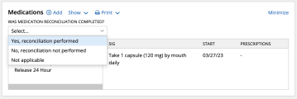
3. Complete the following 4 sections:
- Subjective: commonly referred to as “History of Present Illness”
i. This is from the perspective of the patient and should describe why they are coming into the clinic, any complaints, current medications they are taking/side effects, any health changes, etc.
ii. Always start the subjective with name of patient, age, sex, and why they are coming into clinic
iii. Jane Doe is a 42 year old female who presents to clinic for

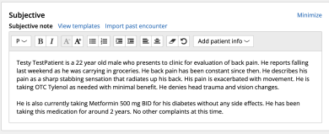
- Objective: physical exam
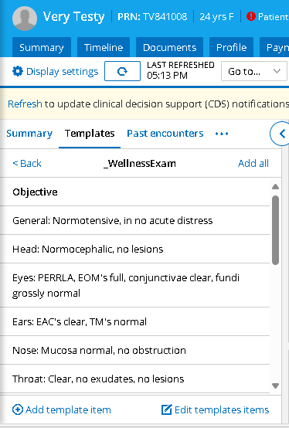
i. Utilize the template: _WellnessExam
1. Select the appropriate choices based off what exam(s) the
provider performs
2. Provider will dictate any abnormal findings to the scribe, you
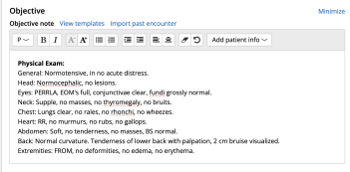
MUST free type abnormal findings and remove normal findings

C. Assessment: diagnoses for the visit (see structure below)
i. Must hit “+ add diagnosis” and add ICD-10 diagnoses that are
pertinent for today’s visit
ii. Then free type the pertinent diagnosis in the assessment portion
iii. If unsure, confirm with the doctor
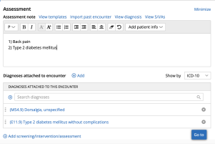
D. Plan: doctors instructions for the patient
i. If medication(s) are ordered/refilled, scribe must document name of medication, dosage, frequency to take, number of pills prescribed, and number of refills ordered:
Ex: “I provided the patient with an escript of Lisinopril 40 mg QD, 90 tablets with 3 refills”
“I provided the patient with a paper script of Metformin 500 mg BID, 180 tablets with 3 refills”

ii. If labs/imaging is ordered, scribe must document what lab/imaging is ordered:

Ex: “I provided the patient with a requisition for a lipid panel, CBC, and CMP to be completed at earliest convenience.”
“I provided the patient with a requisition for a chest XR to be completed at earliest convenience.”

iii. Include “Follow up” information above the attestation and below the plan instructions

iv. Must include SCRIBE ATTESTATION and PROVIDER ATTESTATION at the end of the plan section
NOTE: Search for and utilize the templates and fill in the appropriate name/date/time
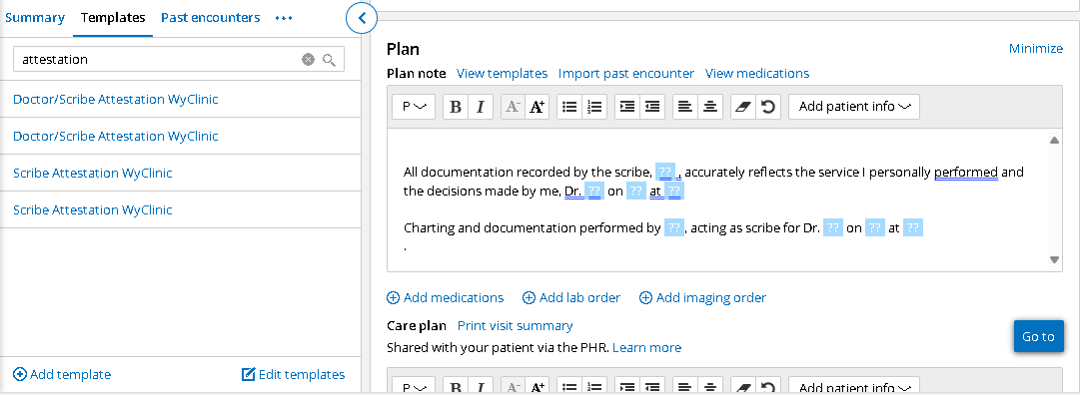
Last updated: 6/21/2024

f. Quality of care:
i. After completing the plan, be sure that the “WAS MEDICATION RECONCILIATION COMPLETED?” is marked as “Yes, reconciliation performed” from the dropdown options:
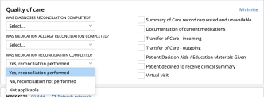

Prepping Notes
1. Once patient is checked in for appointment, you can save time by “prepping” the SOAP note
a. This is time permitting, keep in mind if you add something and it is not discussed/does not relate to today’s visit, you need to DELETE this from the note
2. Subjective:
a. *Name of patient* is a *age* *sex* who presents to clinic for *chief complaint*. They are currently taking *medication(s), dosage, frequency*.
3. Objective:
a. Free type and bold “Physical Exam:” at the start
b. Input common physical exams (general, chest, lungs) will most likely always be done by the physician, it is much easier to prep for this and have to delete than to add it in at the end.

4. Assessment:
a. If patient has chronic conditions, add these in now to save time
b. Add any appropriate ICD-10 diagnoses
5. Plan:
a. Add in the scribe attestation and provider attestation

Prescription/Lab/Imaging Orders
***If using personal laptop, you must add the clinic printer to your computer so you can print lab/imaging forms
General Introduction:
-Goal is to electronically order all prescriptions, labs, and imaging for the patient visit -Always complete orders in “plan section” within the SOAP note
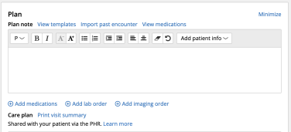

Prescriptions
1. Select + Add medications
2. Select appropriate medications from dropdown (assuming med list has been reconciled by MAs)
3. Type in any new medication(s) being ordered from the provider
4. Queue up the medication for the provider by:
a. Clicking on medication
b. Select “order”
c. Dispense and Unit must be completed (typically 90 tablets if taking medication 1x daily or 180 tablets if taking medication 2x daily)
d. Prescribing provider (the physician that you are working with that day) e. Go to next
5. Sig: how often patient should take medication
6. Refills: how many refills to be giving (typically 3 refills)
7. Script date: today’s date (automatically pulls in)
8. At this point, select “save as draft” NOT “next”
a. Scribes do not have access to order medications, when you select “save as draft” this goes in the provider’s inbox to review and sign
b. If you select “next” you get a hard stop, simply hit “back” > “save as draft”

Labs
(**must be using clinic laptops to enable printing)
1. Select + Add lab order
2. Vendor: Other
3. Tests: select appropriate labs from templates
4. Diagnoses: select appropriate diagnoses to link labs to
5. “Next” x2
6. Payment type: ALWAYS CHANGE TO Provider
7. Primary Provider: ALWAYS USE Edward Bush
8. Ordering Provider: ALWAYS USE Edward Bush
9. Chart note: Attach to today’s visit note
10. Print

Imaging (**must be using clinic laptops to enable printing)
1. Select + Add imaging order
2. Vendor: Other
3. Add a study: select appropriate imaging from templates
4. Diagnoses: select appropriate diagnoses to link imaging to
5. “Next” x2
6. Payment type: ALWAYS CHANGE TO Provider
7. Primary Provider: ALWAYS USE Edward Bush
8. Ordering Provider: ALWAYS USE Edward Bush
9. Chart note: Attach to today’s visit note
10. Print
Common Abbreviations
1. Can utilize common medical abbreviations to save time typing a. Patient history
i. Pt - patient
ii. FHx - family history
iii. PSHx - past surgical history
iv. PMHx - past medical history
v. SHx - social history
b. Common symptoms/complaints
i. CC - chief complaint
ii. C/o - complains of
iii. Sx - symptoms
iv. F/C - fevers, chills
v. CP - chest pain
vi. SOB - shortness of breath
vii. O2 - oxygen
viii. N/V - nausea/vomiting
ix. N/V/D - nausea/vomiting/diarrhea
x. HA - headache
xi. LOC - loss of consciousness
xii. BM - bowel movement
xiii. MVA - motor vehicle accident
c. Medications
i. QD - 1x daily
ii. BID - 2x daily
iii. TID - 3x daily
iv. prn - as needed
v. PO - by mouth
vi. QHS - at every bedtime
vii. OTC - over the counter
d. Labs
i. WNL - within normal limits
ii. nl - normal
iii. Cx - culture
iv. Bx - biopsy
v. CBC - complete blood count
vi. BMP - basic metabolic panel
vii. CMP - comprehensive metabolic panel
viii. LFT’s - liver function tests
ix. Hgb or Hb - hemoglobin
x. HbA1c - hemoglobin A1c
xi. UA - urinalysis
xii. BUN - blood urea nitrogen
xiii. GFR - glomerular filtration rate
e. Imaging
i. US - ultrasound
ii. XR - x-ray
iii. EKG - electrocardiogram
iv. CXR - chest xray
v. CT - computed tomography
vi. MRI - magnetic resonance imaging
f. Plan/Diagnoses
i. Dx - diagnosis
ii. Rx - prescription
iii. MI - myocardial infarction (heart attack)
iv. DM - diabetes mellitus
v. HTN - hypertension
vi. HLD - hyperlipidemia
vii. CA - cancer
viii. NIDDM - non-insulin dependent diabetes mellitus ix. IDDM - insulin dependent diabetes mellitus
x. CAD - coronary artery disease
xi. A fib - atrial fibrillation
xii. UTI - urinary tract infection
xiii. URI - upper respiratory infection
xiv. AOM - acute otitis media (middle ear infection) xv. CHF - congestive heart failure
xvi. CVA - cerebrovascular accident
xvii. CAD - coronary artery disease

---------------------------------------------------------------------------------------

Point of Care Testing

A. Hemoglobin A1C
- The Hemoglobin A1C machine should be on the top shelf of the cabinet in the storage room
  - **Carry the machine with both hands. Do NOT tilt or carry under your arms!**
  - **Diabetic patients are eligible for A1C screening every 3 months**
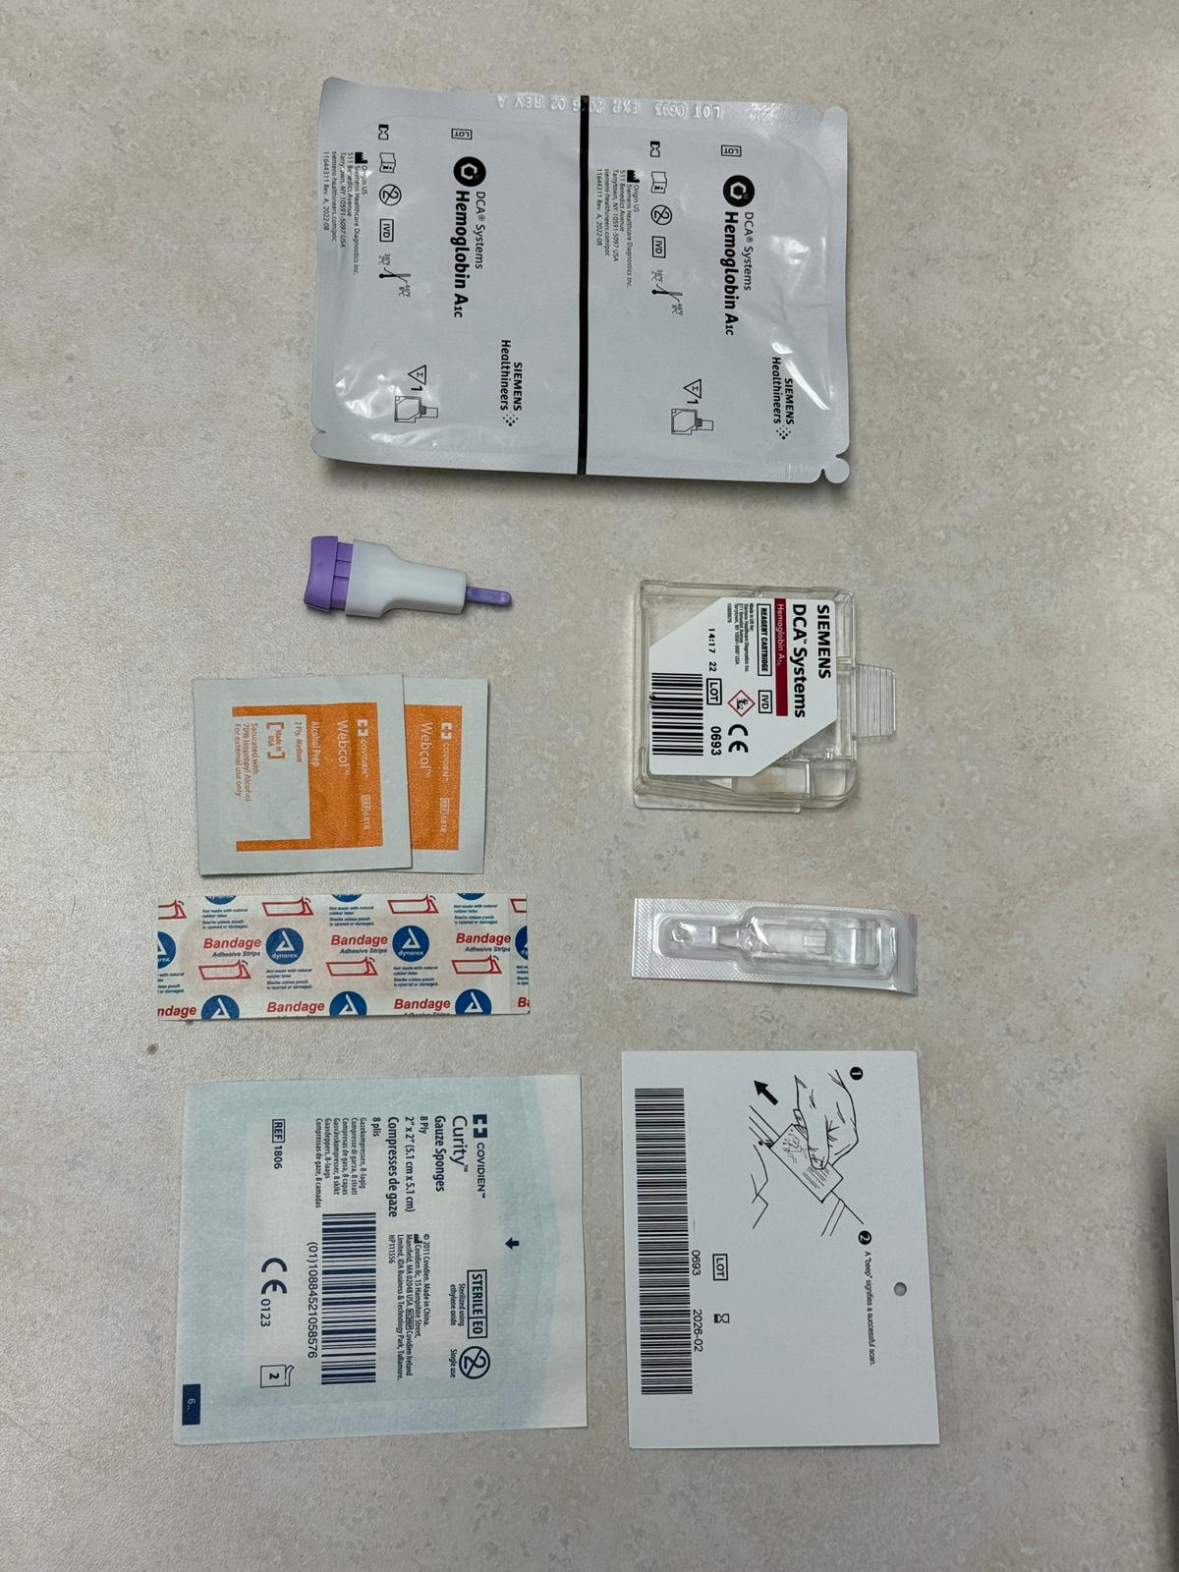
Cartridge
Lancet
Capillary
Alcohol Prep
Band Aid
Gauze
Card to pre-scan new cartridge box
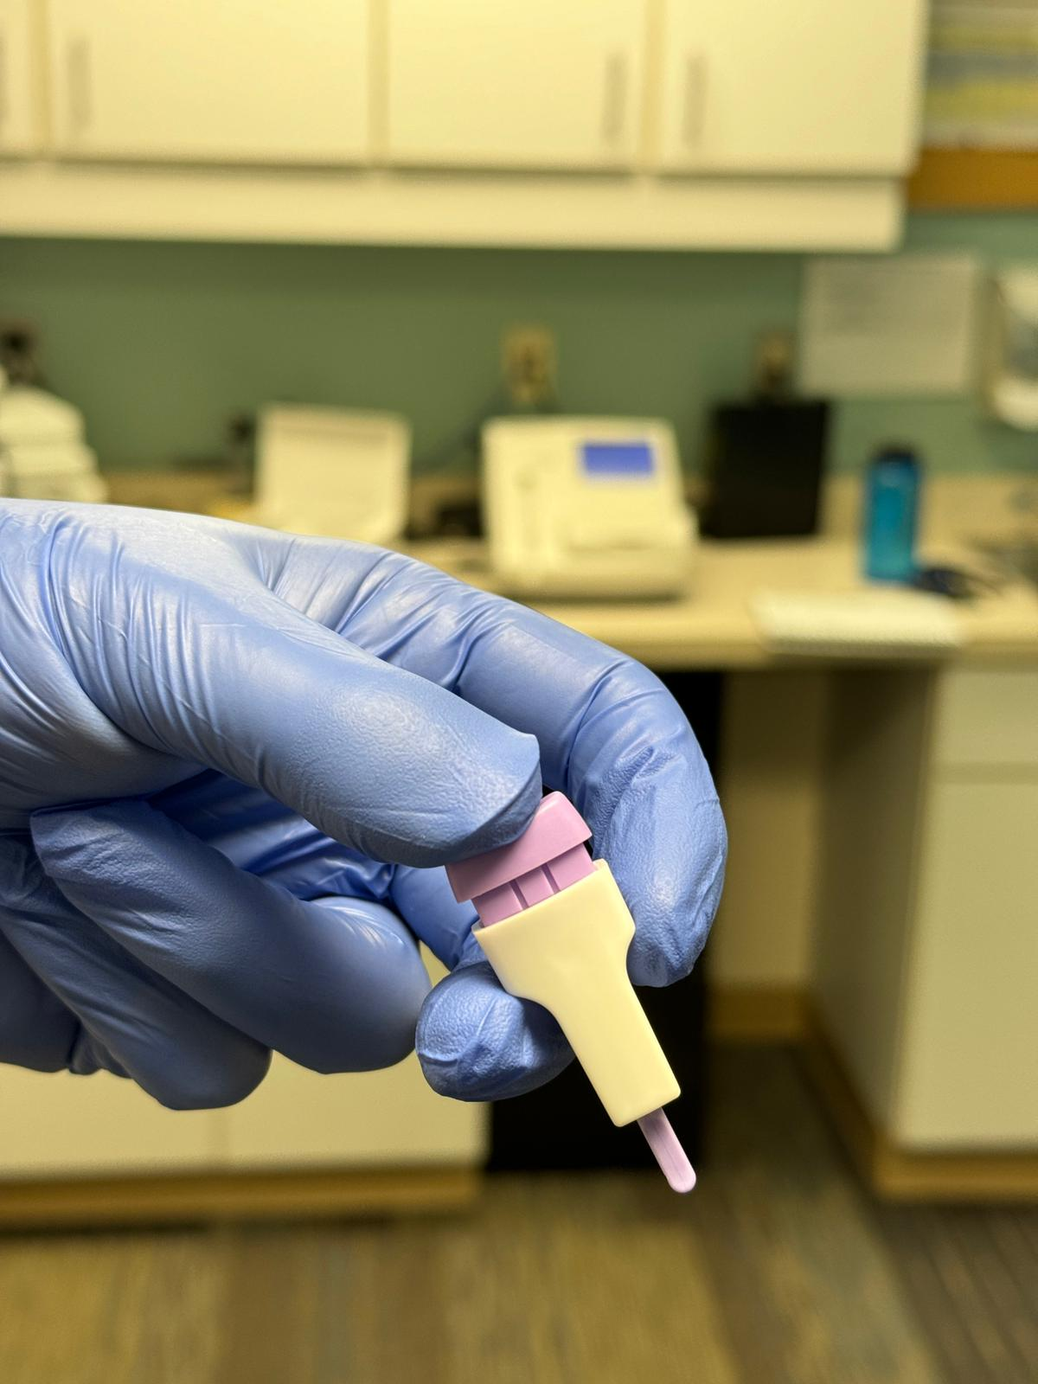
- To load the lancet, twist the thin, purple stick within the front of the lancet, and pull the purple stick to remove it. Note that the lancet is now loaded.
- Once you are ready to obtain a sample:
- Hold the lancet with thumb, forefinger, and middle finger (almost like a syringe) with the purple button against your thumb and white/hole away from you.
- Aim for the side of the tip of the finger to draw blood. Keep the hand below the heart to encourage bleeding

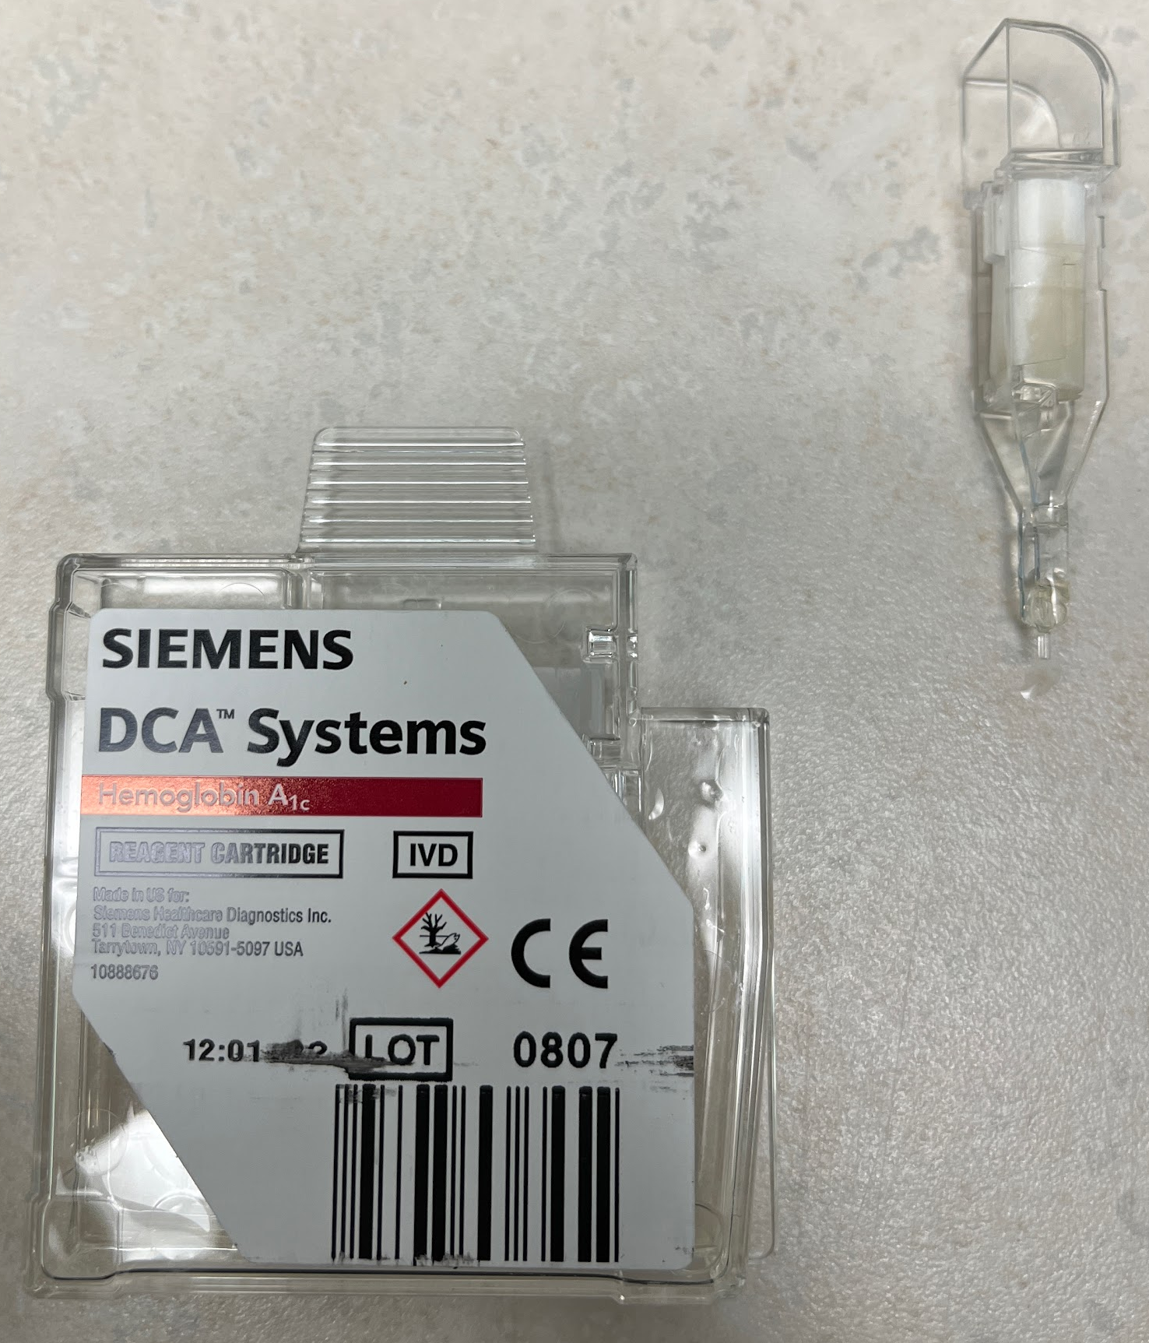
Steps to Obtain Hemoglobin A1C Blood Sample
- Prepare site of injection by rubbing with an alcohol pad
- Place the lancet pen at the desired location and press the purple button to fire the needle
- Gently squeeze the finger to draw out blood. Wipe the first drop with gauze

Capillary Nozzle
- Gently squeeze to get another blood bubble. Contact the bubble with the nozzle of the capillary to obtain a sample to draw blood
- Place pressure on wound with gauze to stop the bleeding (~ 10 seconds)
- Wrap the end of the finger with a bandaid (some patients may decline a bandaid)
- Dispose of the used needle

Inserting into the Hemoglobin A1C machine to analyze sample
- Insert the container into the cartridge (flat side of the container should face inward)
- Scan barcode of cartridge (the screen will indicate that the scan was completed)
- Insert the cartridge into the Hemoglobin A1C machine, barcode to the right
- Pull out the foil from the cartridge
- Close the Hemoglobin A1C machine lid
- Enter arbitrary characters into each item on the screen to continue the test. This information isn’t saved.
- Press “Next”
- The test should be completed within 5 minutes
- Once the test is completed, record the patient name and result into the Hemoglobin A1C tracking book next to the machine. Inform the medical student/resident/attending. If they are in the patient’s room, knock on the door and report the number.
- Remove the cartridge by pressing on the white button and pulling the cartridge out and to the right.
- Record the Hemoglobin A1C result into the lab result section of Practice Fusion. If done correctly, it should autofill into the flowsheet in the encounter.

How to enter Hemoglobin A1C into Practice Fusion
- In the top right corner of the encounter, click the “actions” drop down menu
- Click “enter lab results”
- Under the “Lab” dropdown box select “other”
- Under the “Assigned Provider” dropdown box select the provider that is present on that day
- Ignore the boxes labeled “Order #” and “Accession #”
- In the box labeled “Vendor Name” type “Wyandotte Clinic”
- Collected Date, Report Date, and Received Date will auto-populate as the date and time the lab result was created. If the result is not entered on the date that the lab was performed, input the date and time of the clinic session which the lab was performed on.
- In the box titled “Self Pay Restrictions” select “No Restriction”
- Ignore the box labeled “Comments”
- Under the “Tests” section click “add a test”
- For Hemoglobin A1c, type “4548-4 - Hemoglobin A1c” and select that option
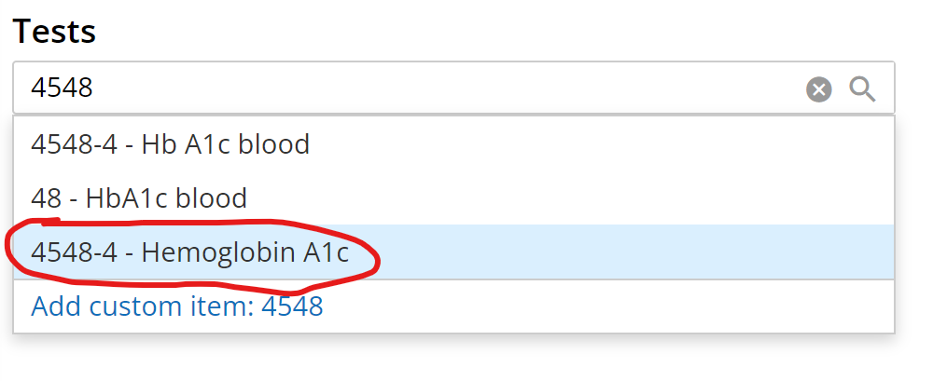
- Fill in the result section with the collected A1c value.
- Ignore the box labeled “Flag”
- The result date will auto-populate as the date and time the lab result was created. If the result is not entered on the date that the lab was performed, input the date and time of the clinic session which the lab was performed on.
- In the box labeled “Status” select “Final”
- Make sure the PHR switch is off
- At the top of the screen click “save” and the task of signing the result will appear in the “tasks” section on the toolbar on the left side of the screen.
- Click the “tasks” button on the toolbar on the left side of the screen
- In the drop down box for the lab result you just created select “reassign”
- Select the provider that you inputted in the lab results and click “reassign”
- Refresh the page to ensure the the lab result is removed from your tasks
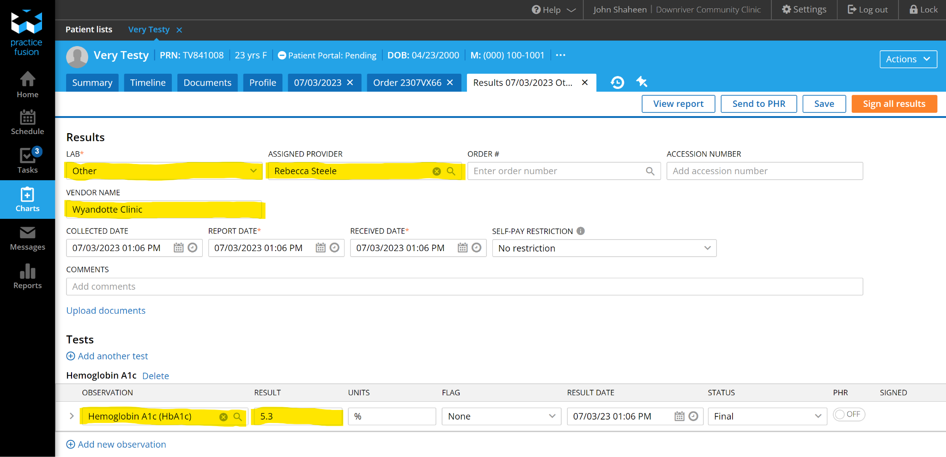

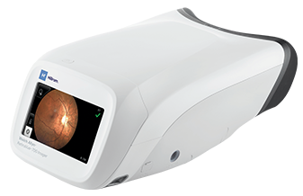
B. Retinal Exams
Device is on the right:
- What is the retinal exam for?
  - Usually the physician will request a patient to get a retinal exam if they have a history of diabetes.
  - The image captured will be sent to an ophthalmologist for review

Setup
- Log-in instructions
  - Website: https://www.retinavue.net/rn_customerportal/
    - Username 1: wyclinic6@gmail.com
    - Password 1: #Clinic@33?
- Make sure the camera is charged
- Ask the patient to sit in a dark room (usually a room next to Admin office) for 10-15 minutes to allow their pupils to dilate (we don’t carry dilation eye drops)
- On homepage, select “Schedule a Patient” and then “Next”
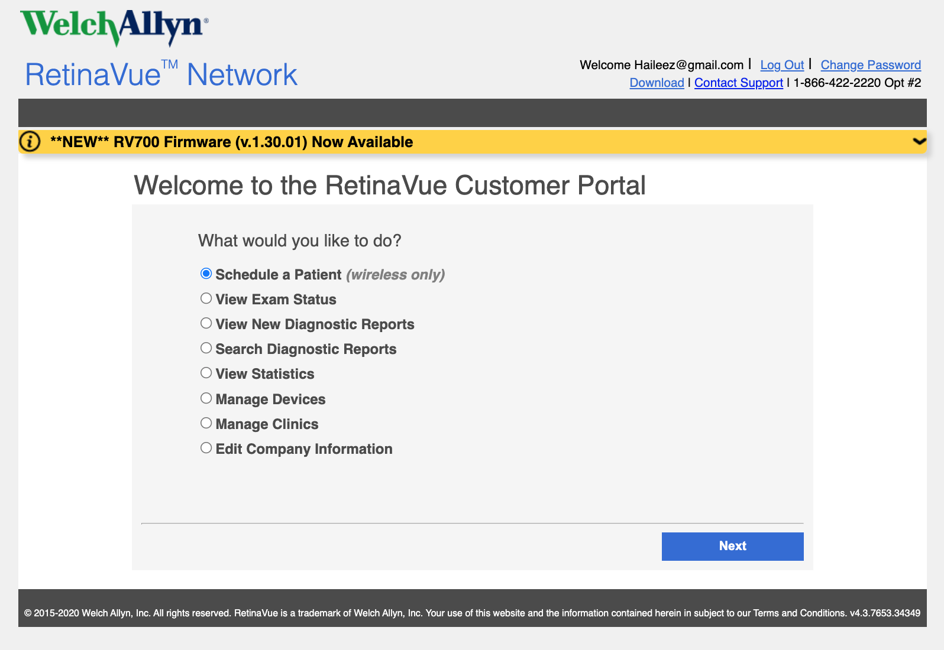
- Select the Clinic (Wyandotte) and fill in the required spaces
  - You can search for a previous patient in the provided space
  - Checkbox the risk factors
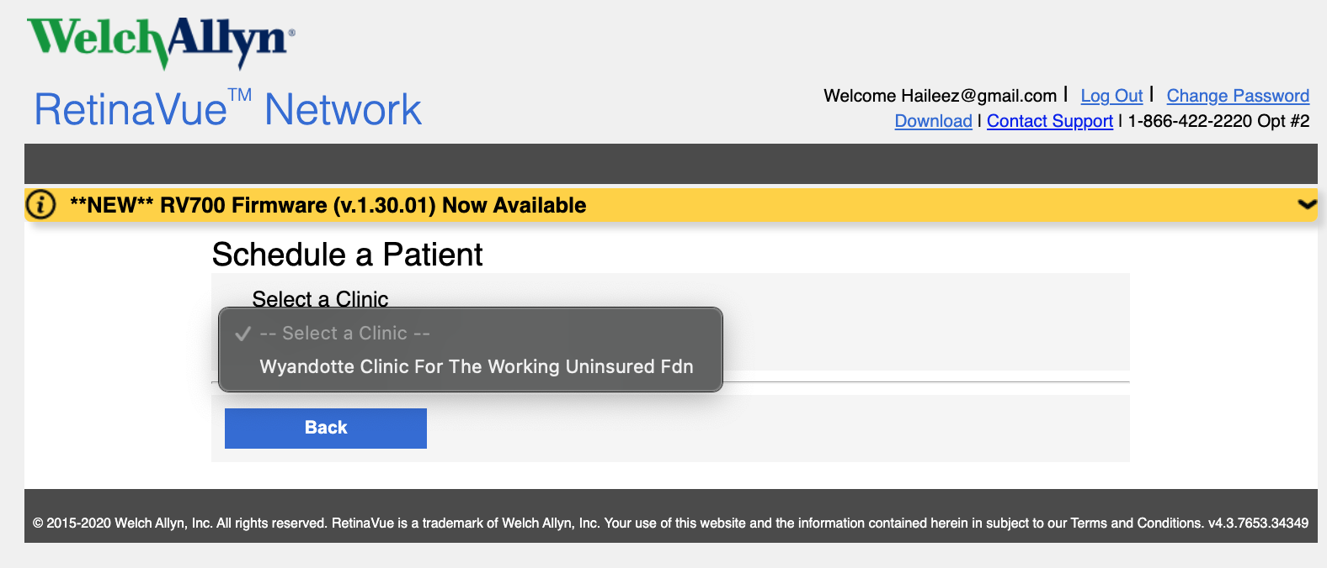
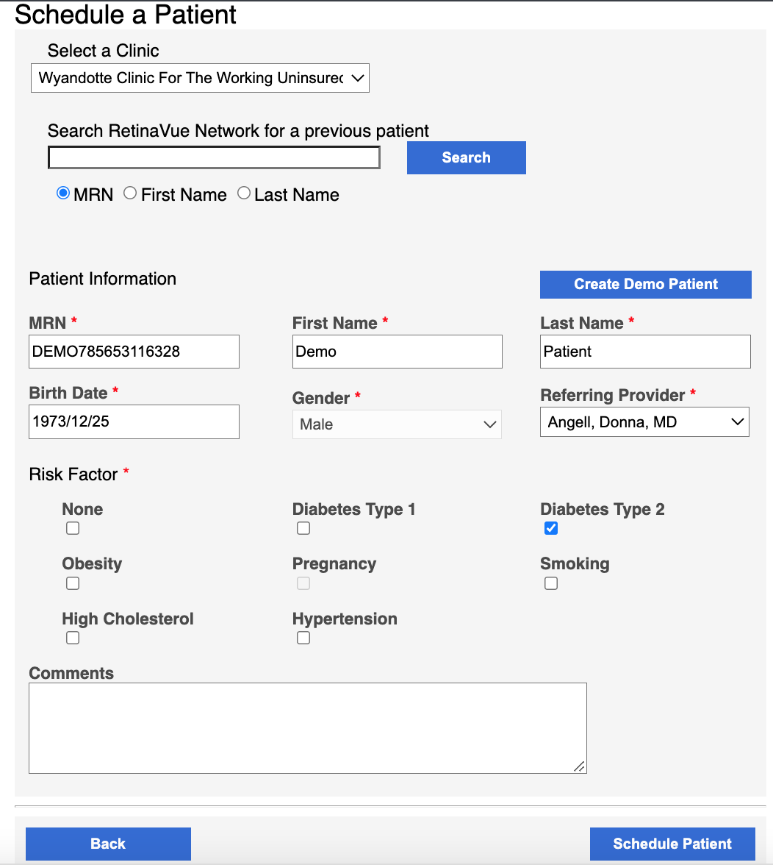
- Click “Schedule a Patient”
- You will see the “View Exam Status” Screen
  - At this point, the camera should show the scheduled patients. You are now ready to proceed to the next section
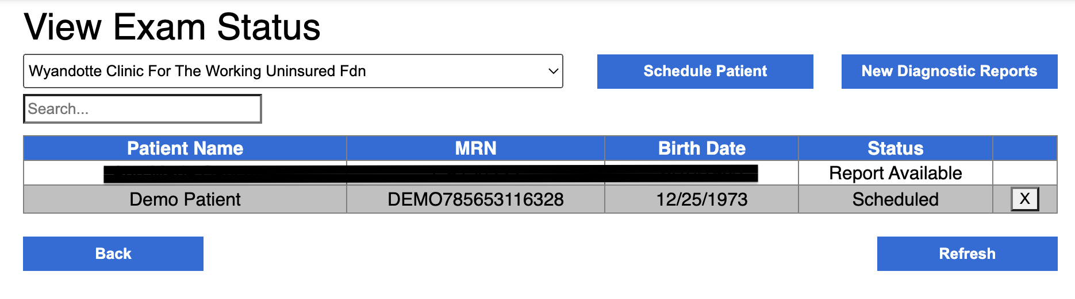

Steps to Capture the Image
It is essential that new M.A.s and those who have not used the Retinavue for a while view the
Video Instructions: https://youtu.be/gOa8k1kgbF4?si=JHXufpjuKer3Pazy
- Wash your hands or use hand sanitizer (you will be placing your hand near the patient’s eye)
- Wipe lens with lens cloth included in kit, and disinfect black, plastic eyepiece that comes in contact with the patient’s face with a sanitizing wipe.
- Sit in front of the patient (walk the patient through the process, especially letting them know that you will be sitting closely in front of them!)
- Start with one eye of your choice (doesn’t matter, as long as you select the correct eye on the screen)
- Hold the camera with two hands, close to the monitor (see picture)
- Slowly move the camera towards the patient. Once you feel the soft part of the camera on the patient, then you can start making micro-adjustments to line up the patient’s pupil with the circle on the screen.
- Ask the patient if they can see the green cross-hairs
- If they can, press start and hold the machine still until it is done taking the image. Before switching to the other eye, the machine will allow the patient a 60-second rest period.
- When the images are complete, double-check the image (it should clearly show the optic disc and fovea/macula). An example image is shown below. More importantly, the image will show a score with a green check mark or red “x.” If there is a red “x” the image must be redone.
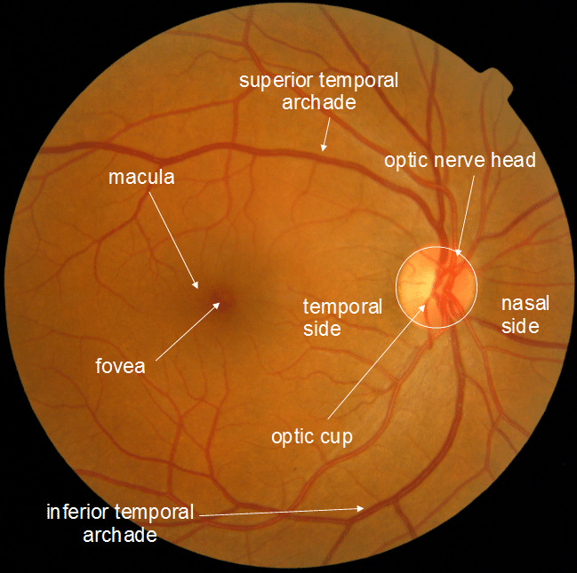
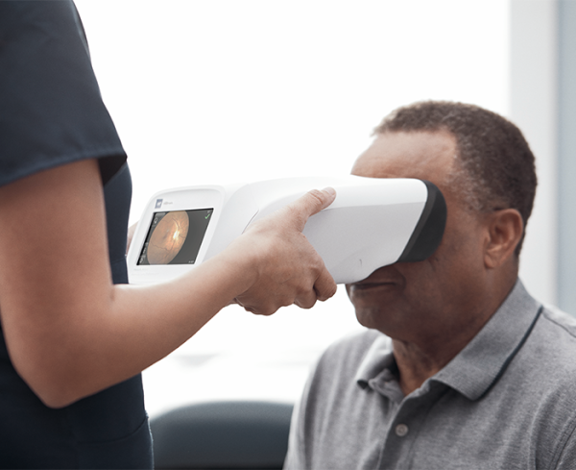

Steps to Record Retinavue Exam in Practice Fusion
- Under the “assessment” section of the SOAP note, click the “add” button next to “Screenings/Interventions/Assessments”
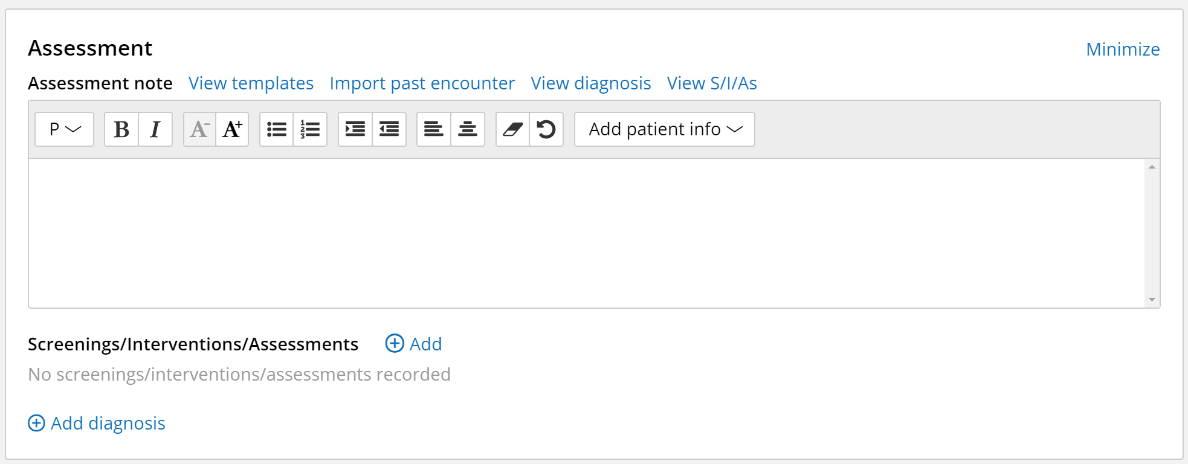

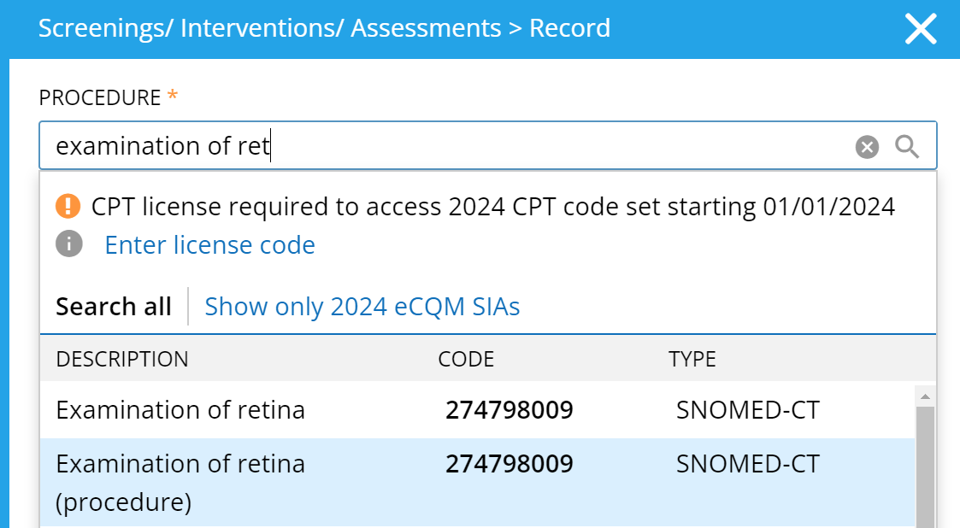
- Under “procedure” type “Examination of Retina (procedure)” and ensure you select the one with the code 274798009

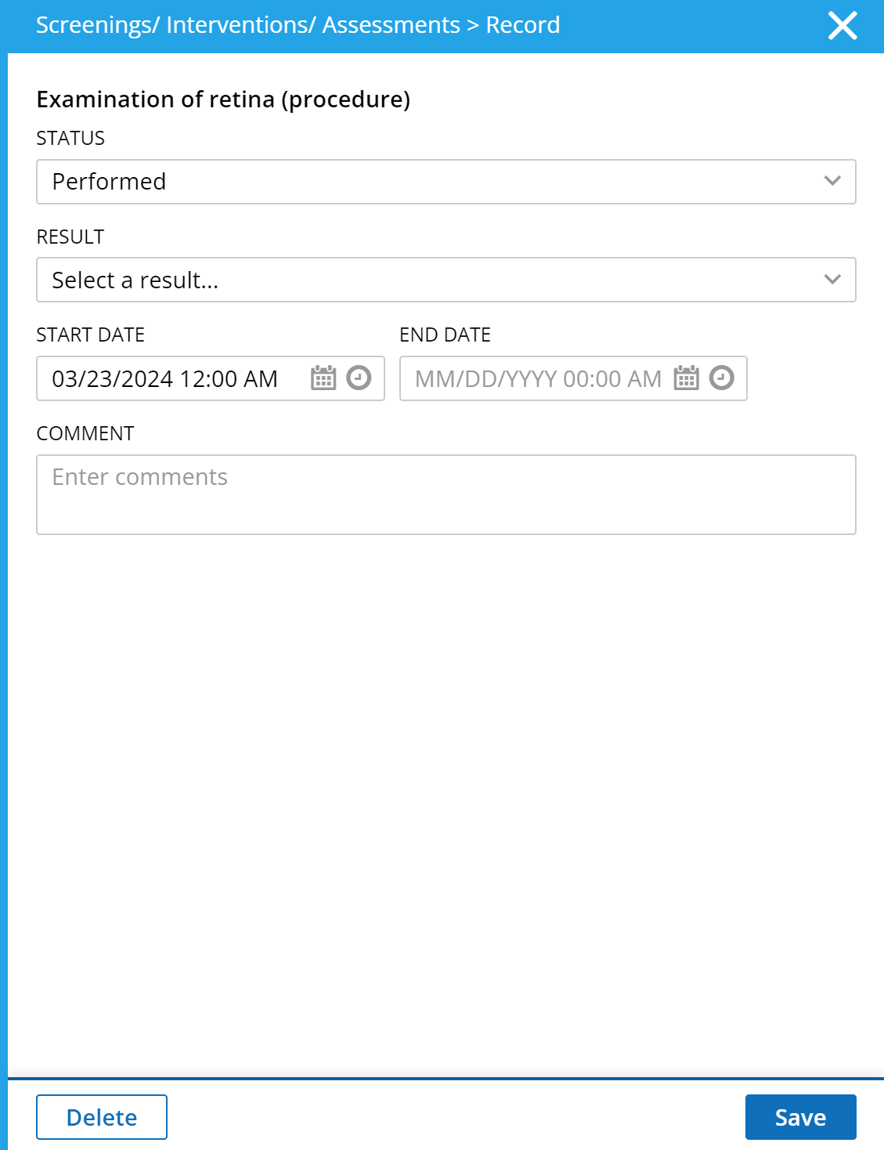
- Under “status” select “performed” and leave “result” blank. Finally, click save.

C. Cologuard
- Follow A1C steps 1-10 as written above.
- Type the desired test such as:
- Cologuard Screening (Presence) - LOINC 77354-9
- Cologuard Screening (Interpretation) - LOINC 77353-1
- Fill in the results section
- Follow A1C steps 13-21 as written above.

D. Adding Immunizations
Immunizations may be requested for school, employment, volunteering, etc.

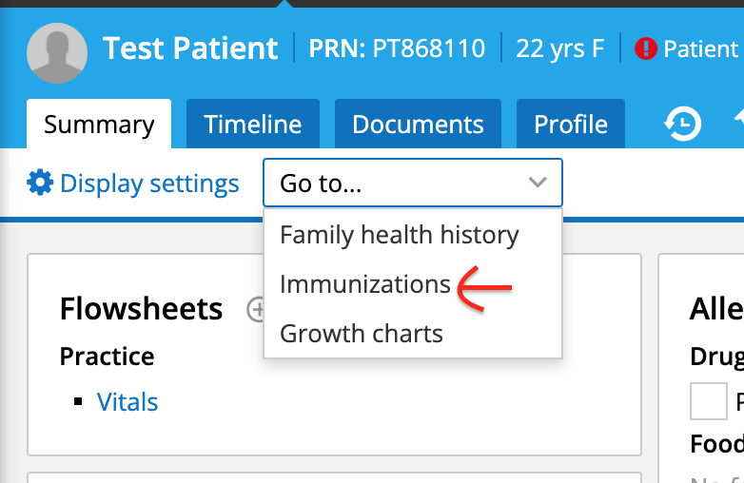
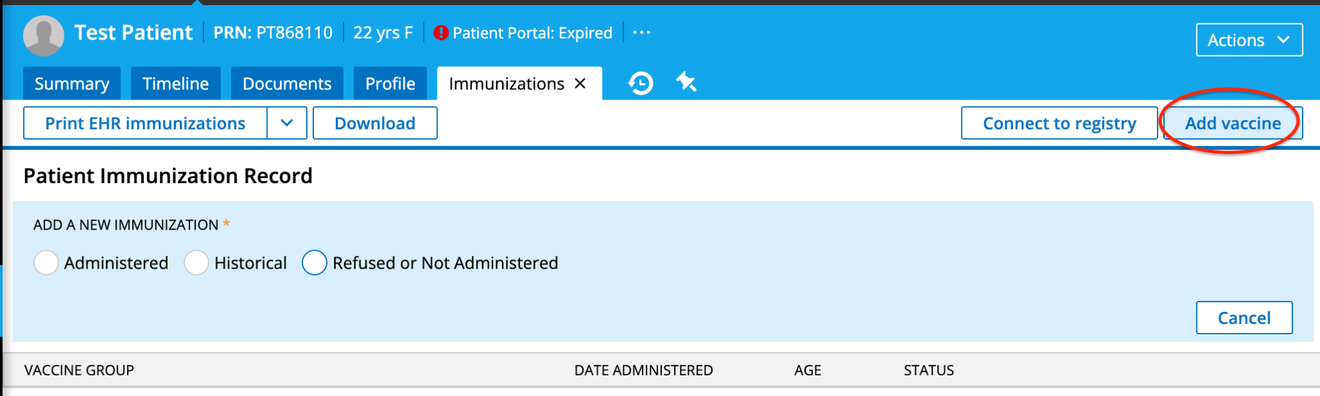
  - Select Administered, Historical, or Refused or Not Administered, then fill out the required fields.

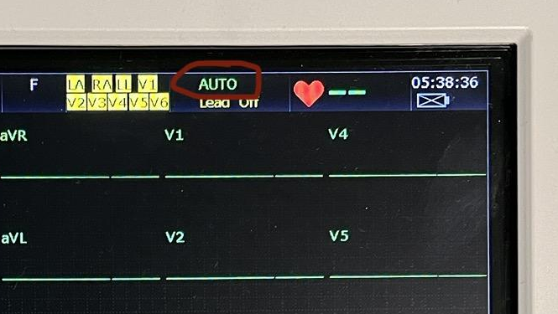
E. EKG
- Turn on EKG machine and prepare electrodes and alcohol pads (you may need to wipe the skin to help the electrodes stick)
- Patient only needs to have their top off (women may keep on their bras, but it may prove difficult to place electrodes. If this is the case, patient can wear a gown with the front open)
- Using the EKG chart as a guide, place the electrodes on the patient
  - Note: It may help put the patient at ease if you explain your next steps or walk them through the process
- Attach the leads
- Make sure the EKG screen is configured properly
  - Use the “Mode” button to toggle between the screens. Select the screen shown above. Don’t use the screen with blue/purple highlights
- Run the EKG after ensuring the waveforms are showing up clearly and give printout to the doctor
- Refilling EKG paper
  - Refill EKG paper can be found in a brown box labeled “EKG Paper” in the silver, tall cabinet in Nancy’s office
  - Insert the stack of paper into the machine as shown in the picture
  - Make sure the EKG papers run properly when printing
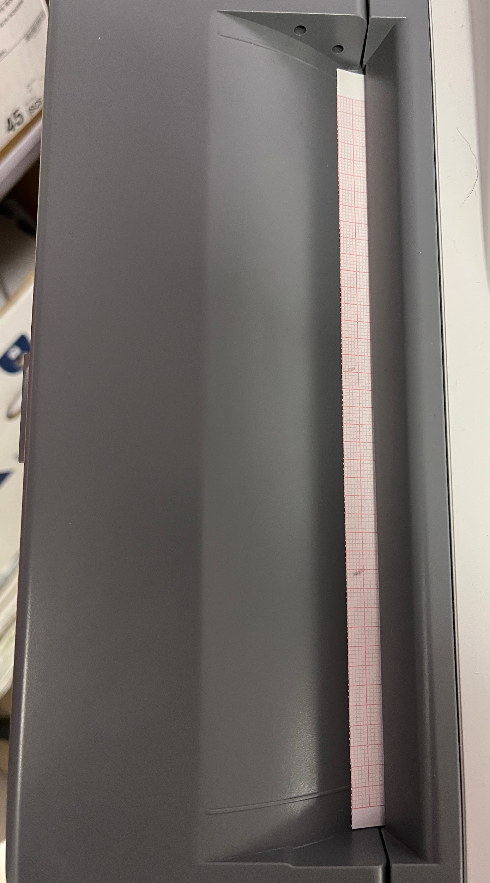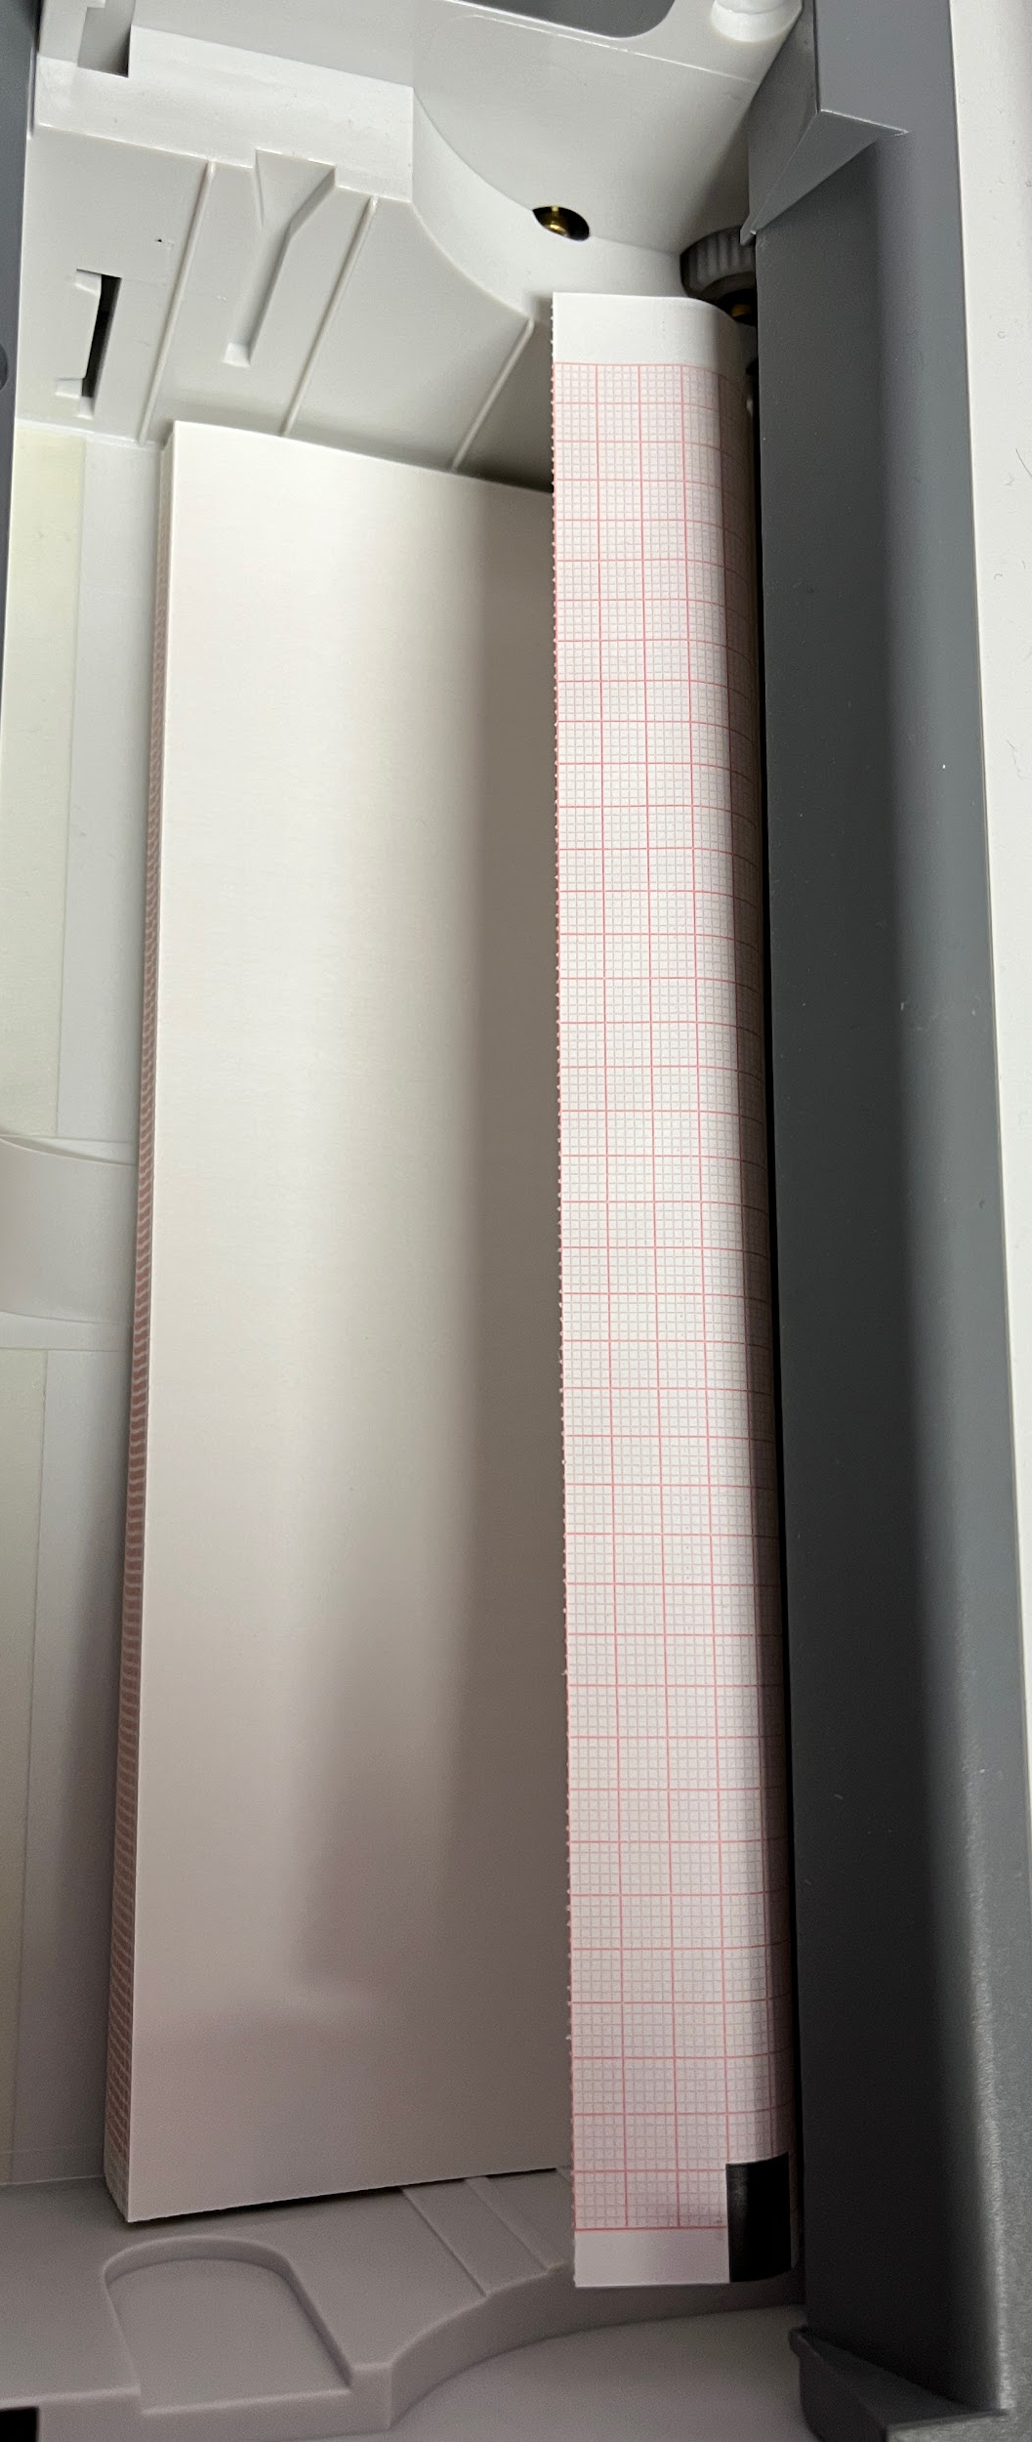

GYN Nights

Room setup

- Turn on lights in rooms #5 and #6 when Dr. Wolf is in the clinic
  - Make sure Dr. Wolf’s exam sheet is in the patient folder
- Move the supply cart for WyClinic (yellow cart) from Room 5 into the nurse’s station (location doesn’t matter, as long as it’s easily accessible with minimal disruption to patient or doctor)
  - Note: if Dr. Wolf is NOT in the clinic, room 5 and 6 should NOT be used. Leave the cart in the room.
- Gather the gowns and sheets for the expected number of patients and place them on the counter in the central space by the patient rooms
  - The sheets and gowns can be found in the storage closet across the office by the OMT room
  - If the beds don’t have a sheet on them, make sure you place one on
- Gather speculum, spatula, ThinPrep collection cup, and lubricant
  - Use plastic speculum (the others are for the regular clinic). Have all three speculum sizes available for the doctor to choose in the room.
- When the patient is in the room, and is here for a breast/pelvic exam (or upon request by doctor to have patient change), have them change into the gown, with the opening on front (makes breast exam easier)
  - Some doctors may prefer to talk to the patient prior to them getting changed, so check with the doctor on their preference (ask for doctor’s preference at the START of the clinic)

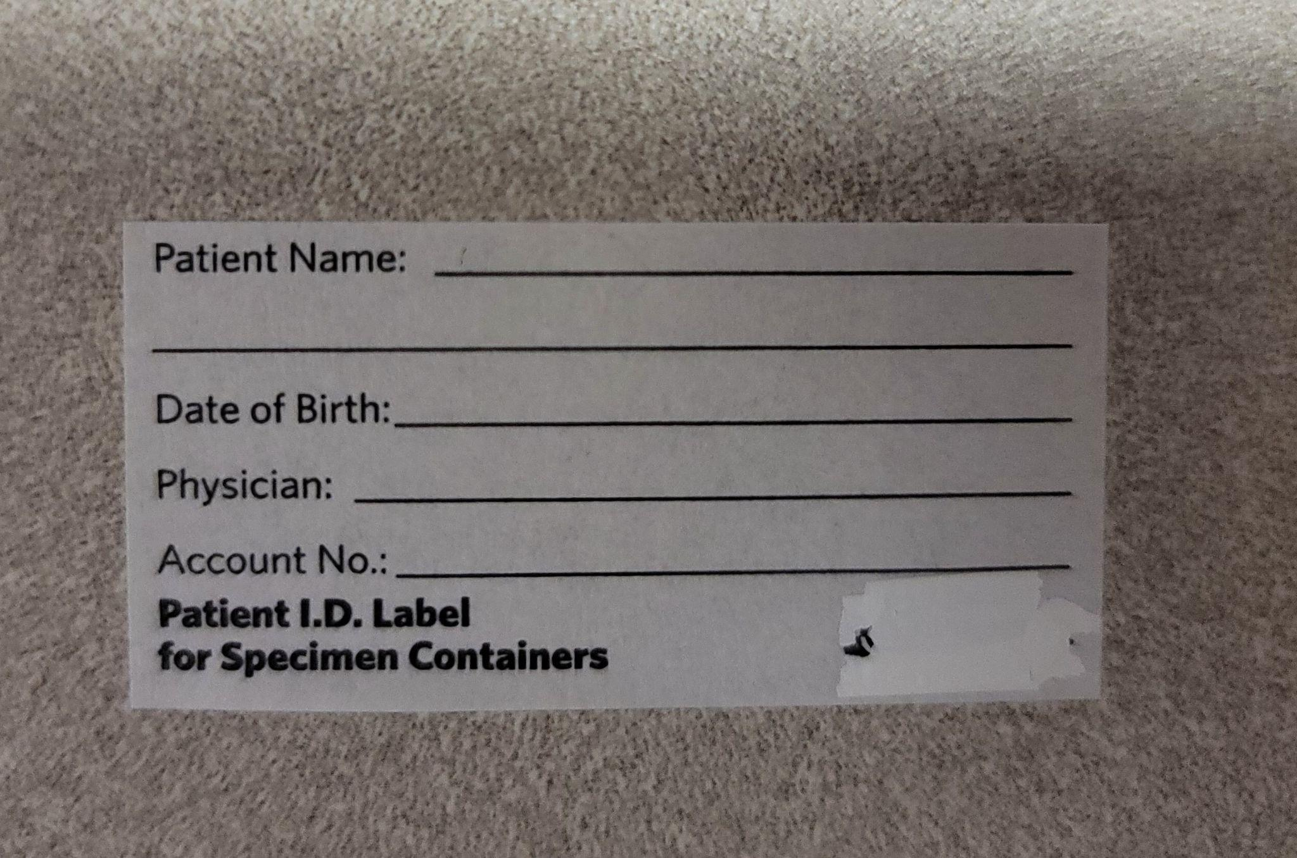
Assisting Pap Smears
- Setting Up the Tray
  - Place a ThinPrep Pap Test container and place specimen sticker on it (see picture on the right)
  - Take a sticker from the lab order form (white, bottom right corner; see form picture below) and place it on the container
  - Place gauze pad on metal tray and assemble the items as shown below
    - Speculum, spatula, brush, container, and lubricant
  - !!Do NOT touch the white, sterile part with bare hands!!

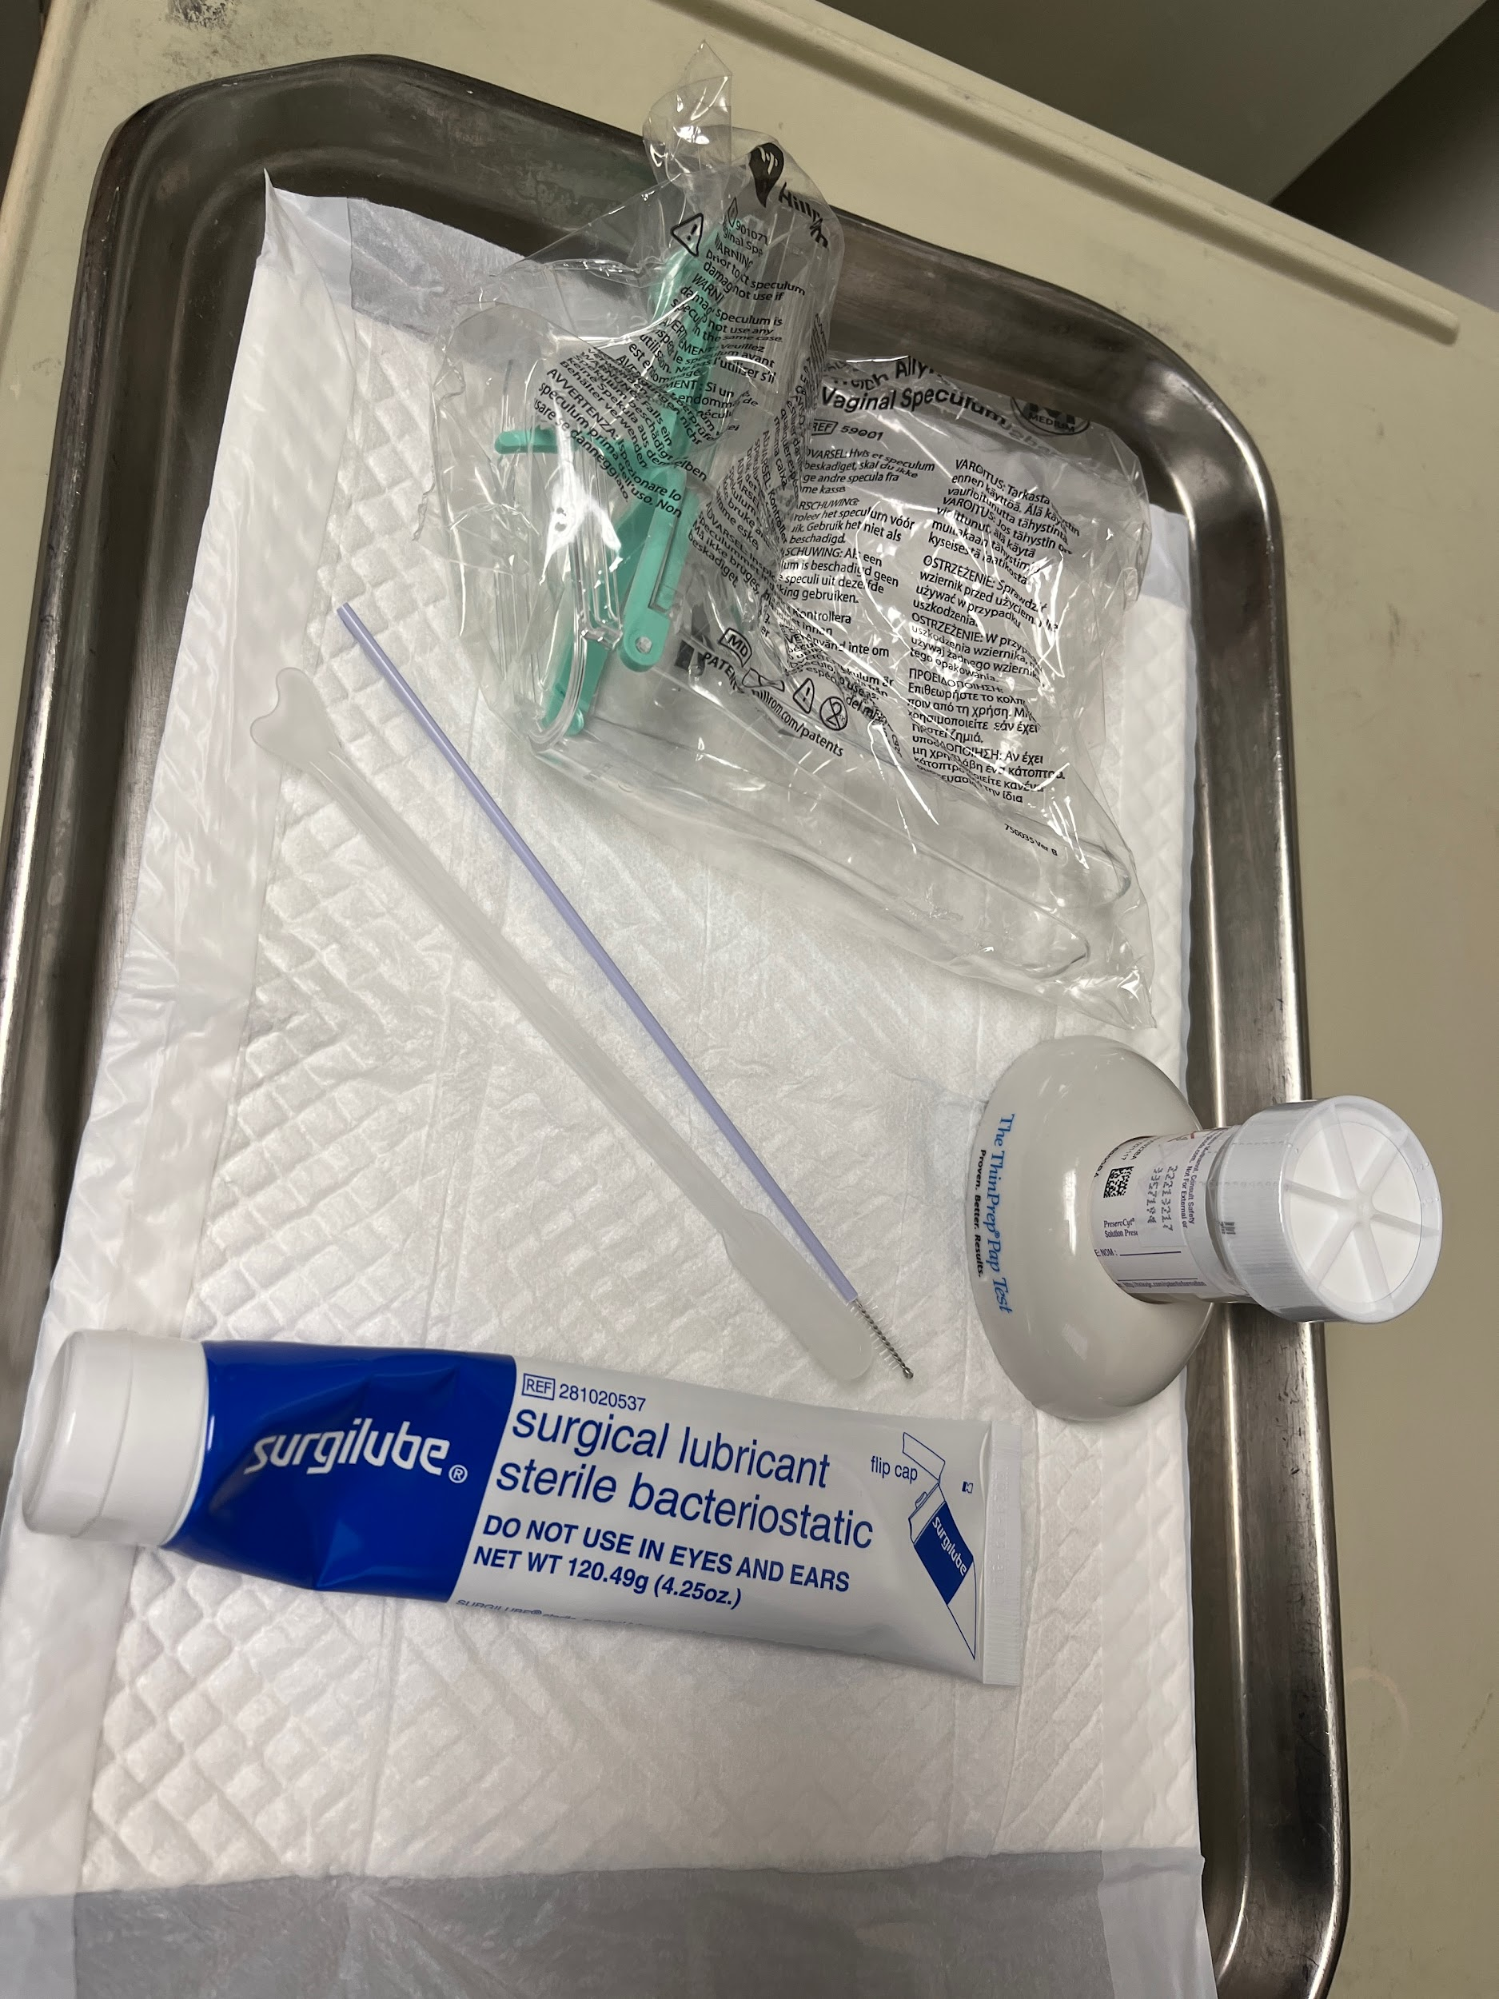
- During the procedure (Remember gloves!)
  - Crack the container lid and unscrew, leaving the lid in place. This will make it easier for when you need to place the brush into the container, since all you need to do is lift the lid off with one hand, while the other may be used to help hold materials
  - Open the speculum package on the handle end. While grabbing the “beak”, hand it to the doctor, who can then reach in and grab the speculum by the handle
  - Apply lubricant onto the beak as directed by doctor
  - Grab the brush and spatula, and be ready to hand it to the doctor when requested
  - When the swab is complete, place both spatula and brush into the ThinPrep container and swish lightly to deposit the tissue
    - You may gently scrape off the tissue if it’s not coming off easily. Be careful as to not damage the sample!
- Dispose of the used materials in garbage bin in the room
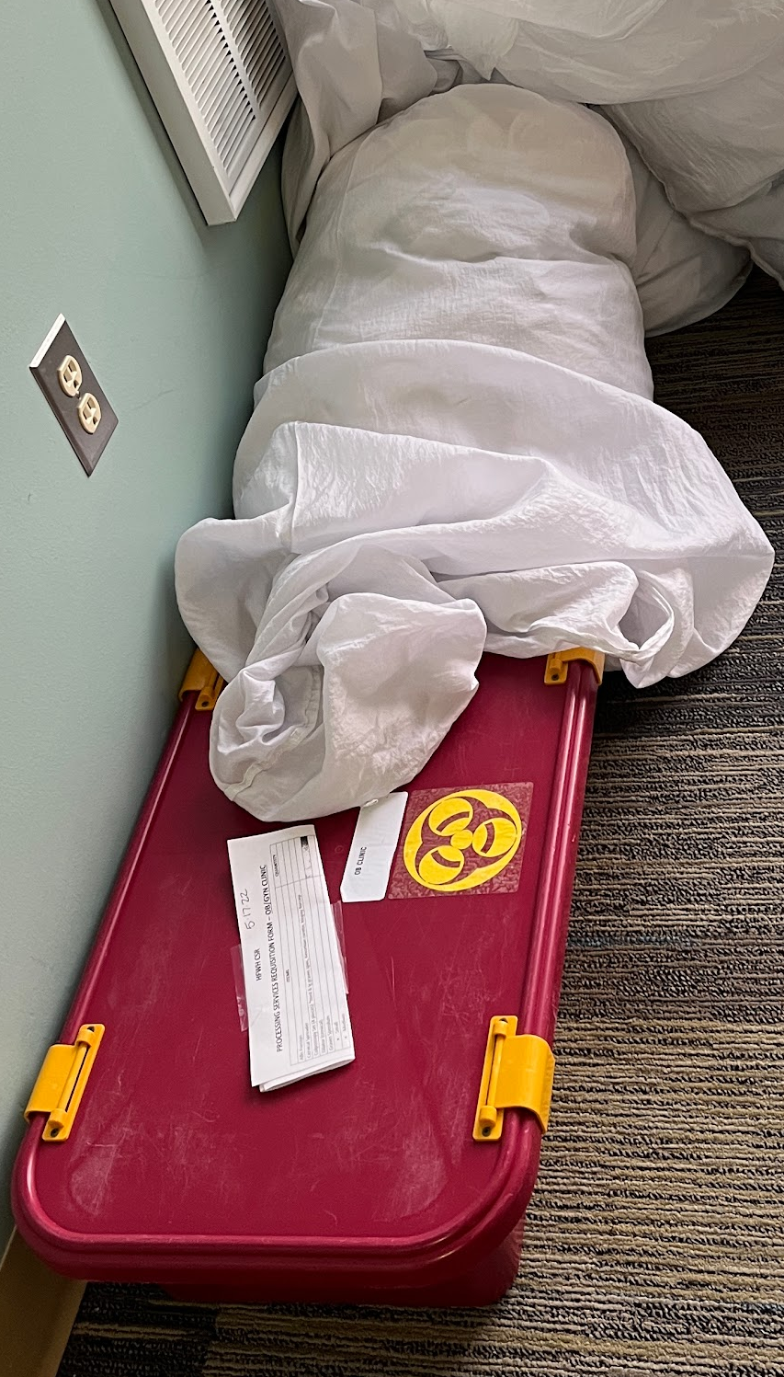
  - Note: metal speculum must NEVER be used during WyClinic sessions. If one is accidentally used, it must be placed in the red biohazard bin usually located by the exit across the OMT room (be careful to not confuse with red biohazard bins labeled with a green CLEAN sticker. Do NOT touch the CLEAN bin.). You must also update the white form taped to the top of the bin with the correct number of speculums the bin contains.

Henry Ford Wyandotte Hospital Lab Process
- The driver will pick up labs at approximately 7:30 pm on Tuesdays.
- On Saturday, we will call the lab to arrange pickup at 734.246.6034 (lab main office line)
- The contact for the driver for lab pickup is Lamont, phone # is 313.598.7038.
The HFWH Lab may be contacted at 734.246.6034 for pickup on days/times other than Tuesdays at 7:30 pm, for example, Saturday mornings.

The HFWH Lab Manager is Christina Berent, Phone) 734.246.6922
Fax:) 734.246.6918
if there are any questions.

Specimens & Containers
The containers are located in a bin in the nursing station near where we keep the A1C machine, in the lower cabinet.
We use 3 types of containers:
- Thin Prep – PAP tests, STI (Gonorrhea, Chlamydia)
- Culture - 2 colors of Aptima tubes, 1 BBD tube (white) for yeast
- Endocervical specimens use purple swabs
- Vaginal specimens use orange swabs (cannot be used for cervix)
- Biopsy (Endometrial, skin)
Specimen Acceptability Criteria
- Specimens must be collected in proper containers and must not be expired.
- Samples that are improperly labeled or stored may not be processed.
- Specimens may need to be rejected for quality purposes if the quantity is not sufficient, or if the sample is clotted or hemolyzed.

Specimen Labeling Requirements
For patient safety, each specimen container must have a label firmly affixed to the container, not the container lid or biohazard specimen transport bag, that contains the following minimum information:
Label
- Patient’s full name (last name, first name)
- Patient’s birth date
- Date and time of specimen collection
- Specimen description = test name, and source of the specimen

Requisition (Order) Create in PF with Vendor = Other, Add HFWH

Properly labeled specimen(s) must be accompanied by a requisition(electronic order) containing the following information: Note: Most of the information will be generated by PF lab order. Clinic admin will be responsible for entering the lab orders into PF and EPIC until volunteers are trained.

- Patient’s full name (last name, first name)
- Patient’s medical record number (use MR # from previous HFWH tests if available. If there is no HFWH #, use birth date
- Date and time of specimen collection
- Source or site of specimen (non-blood body fluids, microbiology, cytology, and surgical tissue specimens)
- Test(s) requested (the doctor will decide)
- Ordering physician name (use Dr. Bush)
- ICD-10 diagnostic code
- All orders should be placed as “LAB COLLECT, FUTURE” not Clinic Collect

The person who collects a specimen from a patient is responsible for establishing the identity of both the patient and the specimen(s) at the time of collection. Patient identification must be verified immediately before any specimen collection procedure.

Thin Prep
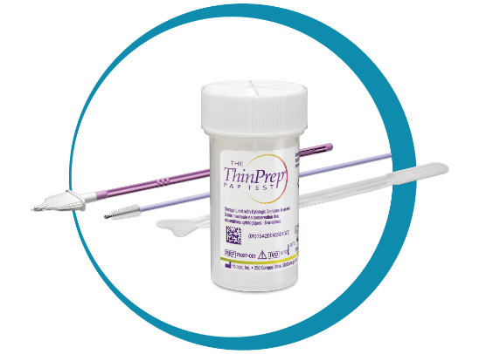

Cultures
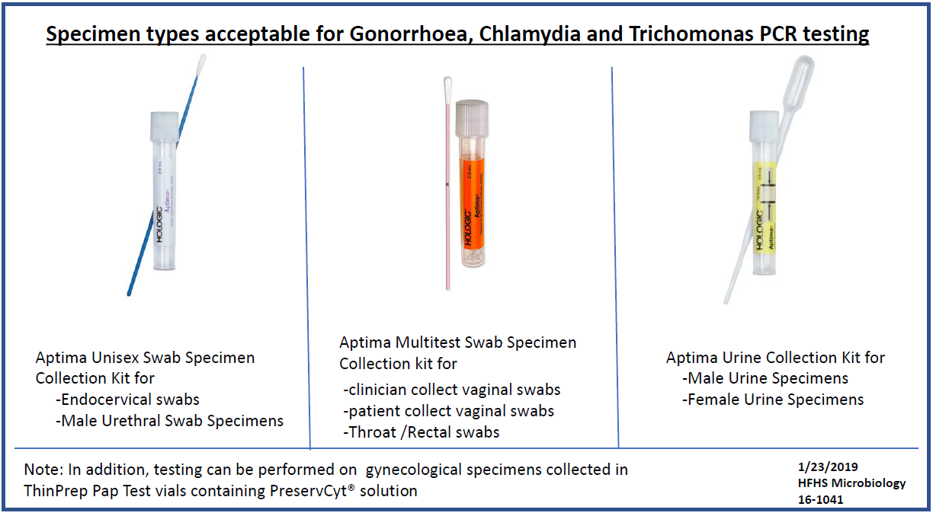
Purple Swab, White Label Orange Swab & Label White Swab, Yellow Label

Biopsy Containers with Formalin (Endometrial, dermatology tissue)
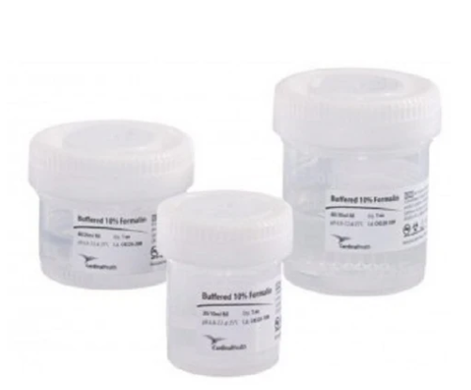

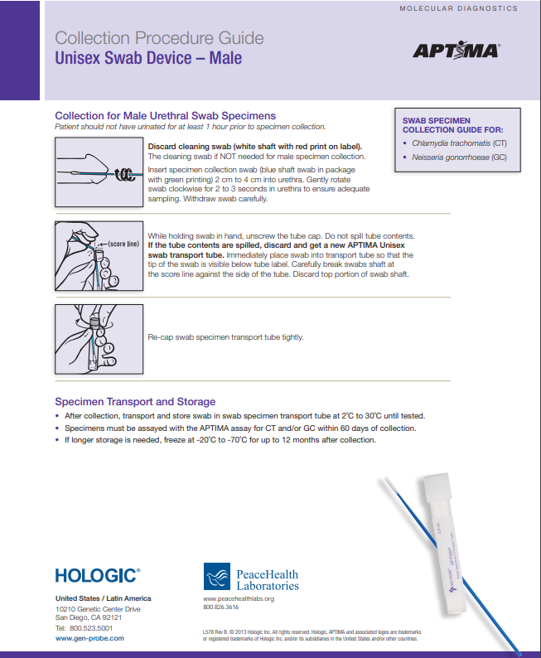

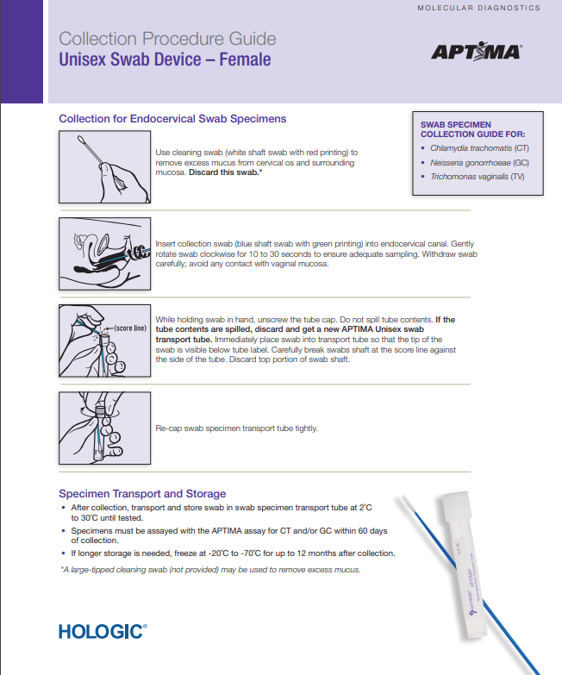

HFWH LAB Commonly Used TEST CODES
(note: PF codes may be different)
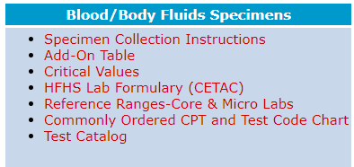
All test and specimen information can be found at the HFWH Lab test site at: https://lug.hfhs.org/home/home.asp
User name: Lug Password: HOMELUG
Select Test Catalog on the last line of the table on the right.

- PAP Pap Test (Thin Prep)
- HPV HPV 16-18 (Thin Prep)
- RNAT Trichomonas (Orange Swab)
- RNAGT Gonorrhea (Orange Swab)
- RNACT Chlamydia (Orange Swab)
- VAGSC Vaginitis Screen (BBL Culture swab)
- YEAST Yeast (White swab)
Note: Thin Prep can include Pap, Gonorrhea, and Chlamydia, but have to add Trichomonas as a separate test (orange swab).
Refer to the chart below and the highlighted tests:
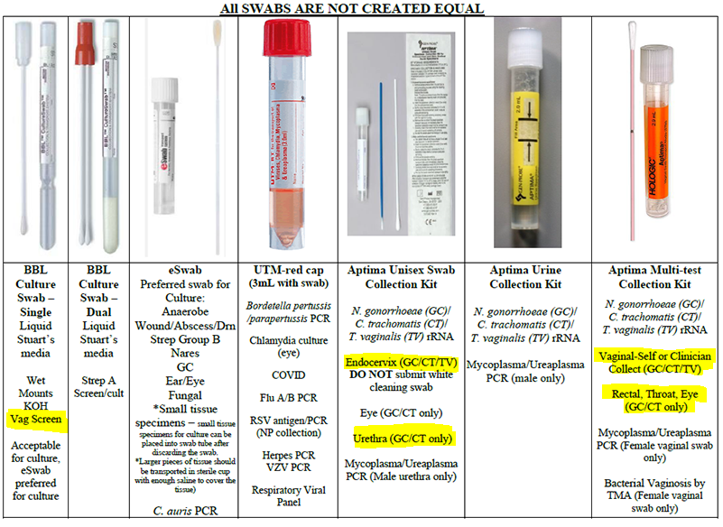
All 3 Aptima swabs (yellow, purple and orange) test for Chlamydia trachomatis (CT)/ Neisseria gonorrhoeae (GC)/ Trichomonas vaginalis (TV). However, which swab is used changes depending on the source. The vaginosis screen includes yeast, clue cells and Trich Ag, which is a BBL swab that we sent you. You can access this chart at https://lug.hfhs.org/home/home.asp Navigate to Blood/Body Fluid lab specimens, then click the Microbiology tab.

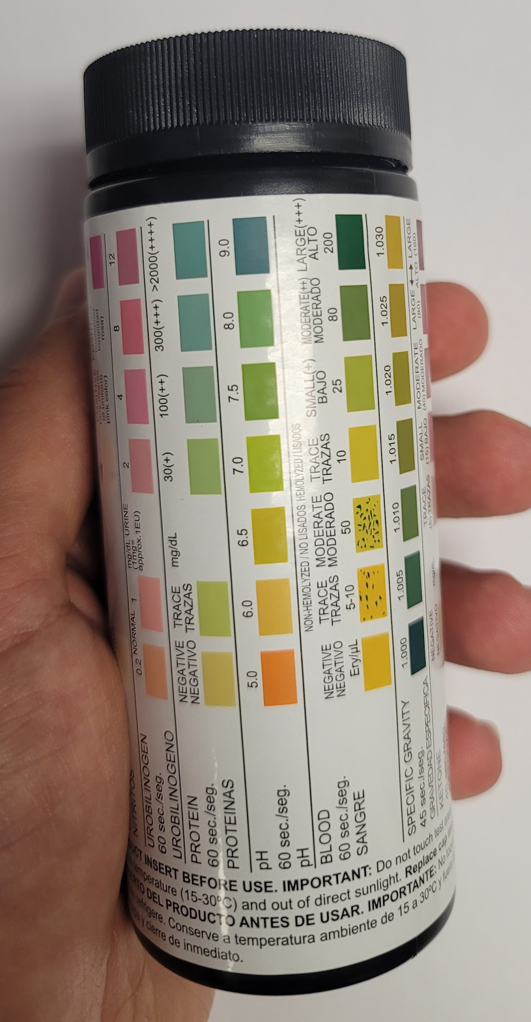
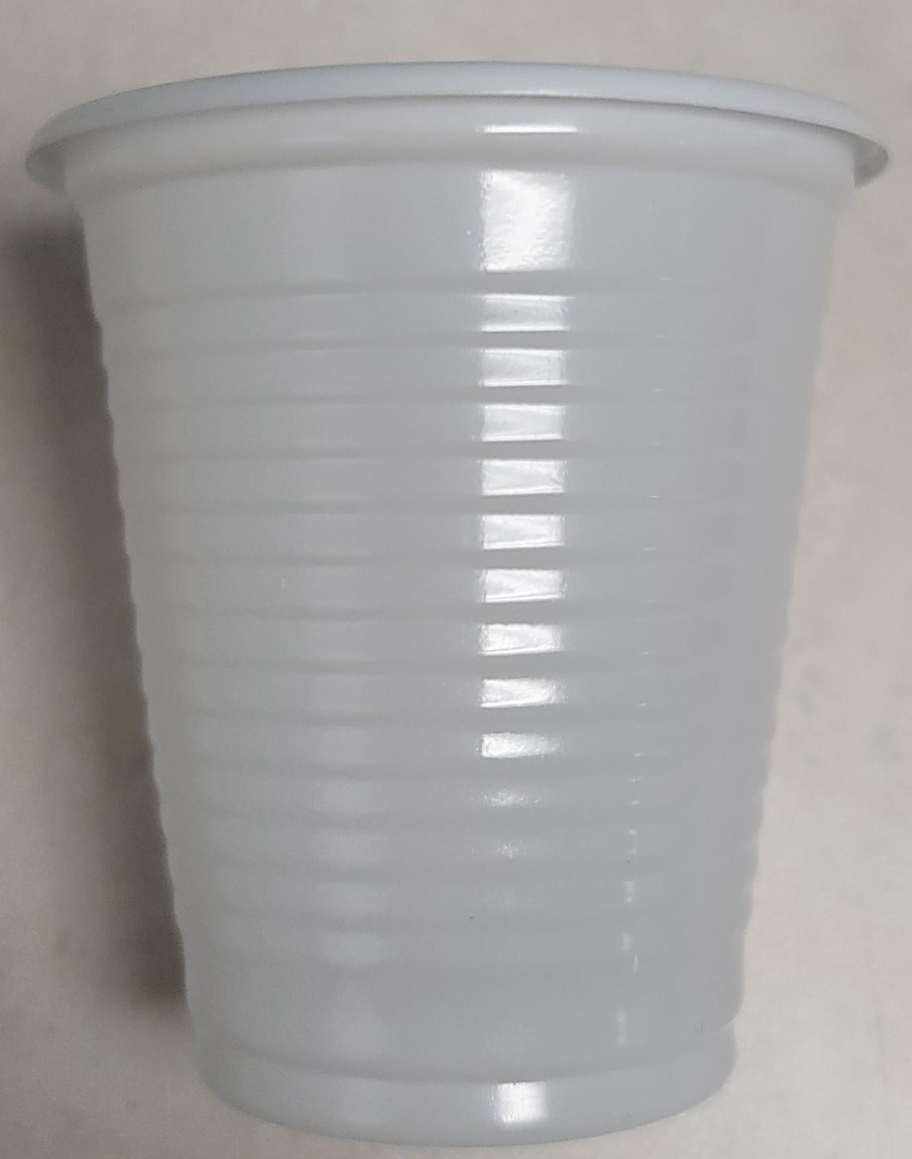
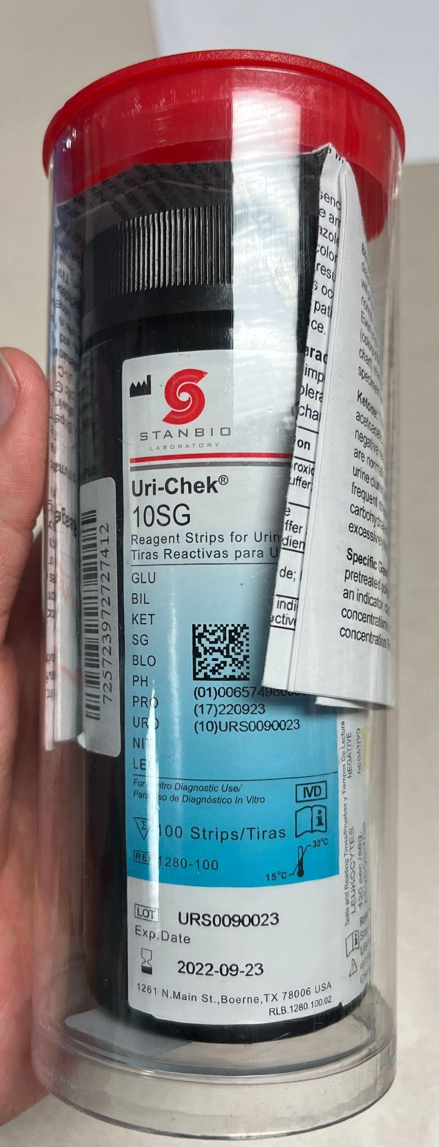
Miscellaneous
- Urine Tests
- Cups used for urinalysis are shown on the right. They are located in the “Wyandotte Clinic” lab cabinet.
- Test strips (shown on right) are stored in the tall, silver cabinet in Nancy’s office.
- The urinalysis results sheets can be found in a folder in the front desk cart

- Preparation
    - Place one or two sheets of tissue on the cart and on the toilet tank in the bathroom
    - Place cup on the tissues
    - Direct the patient to urinate into the cup, and to place the cup on the toilet tank
    - Place the cup onto the tissues on the cart (remember gloves!)
    - Dip the urine test strip far enough to cover all the fields and lay the strip on top of the tissue
    - The bottle describes how long to wait for each section to provide results
    - Compare the test strip colors to that on the bottle and read off the results
      - Best to have another volunteer nearby to record the results
    - Provide the results to the physician
- List of commonly requested medical equipment and their locations
Betadine and gauze pads to apply Betadine  Lidocaine with epinephrine  Lidocaine without epinephrine  Depo Medrol for joint injections  Found in Storage Room | 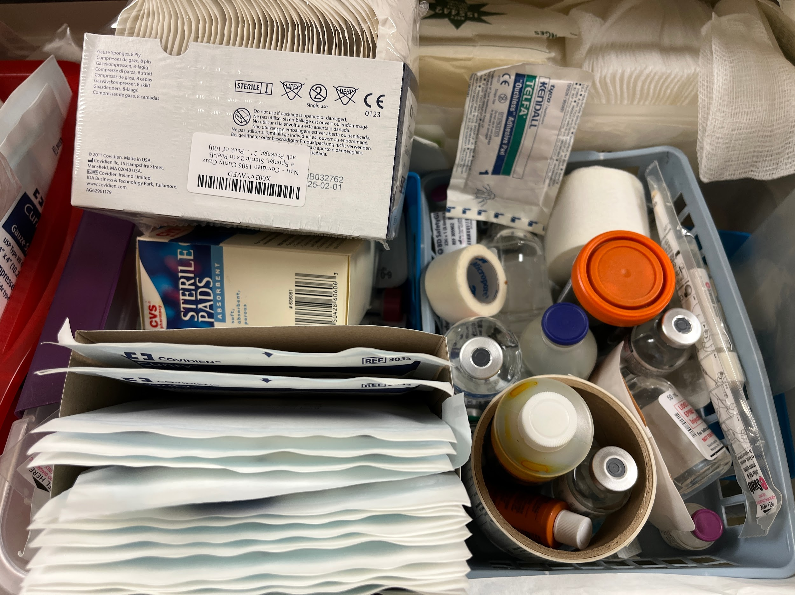
Scalpel  Found in Storage Room | 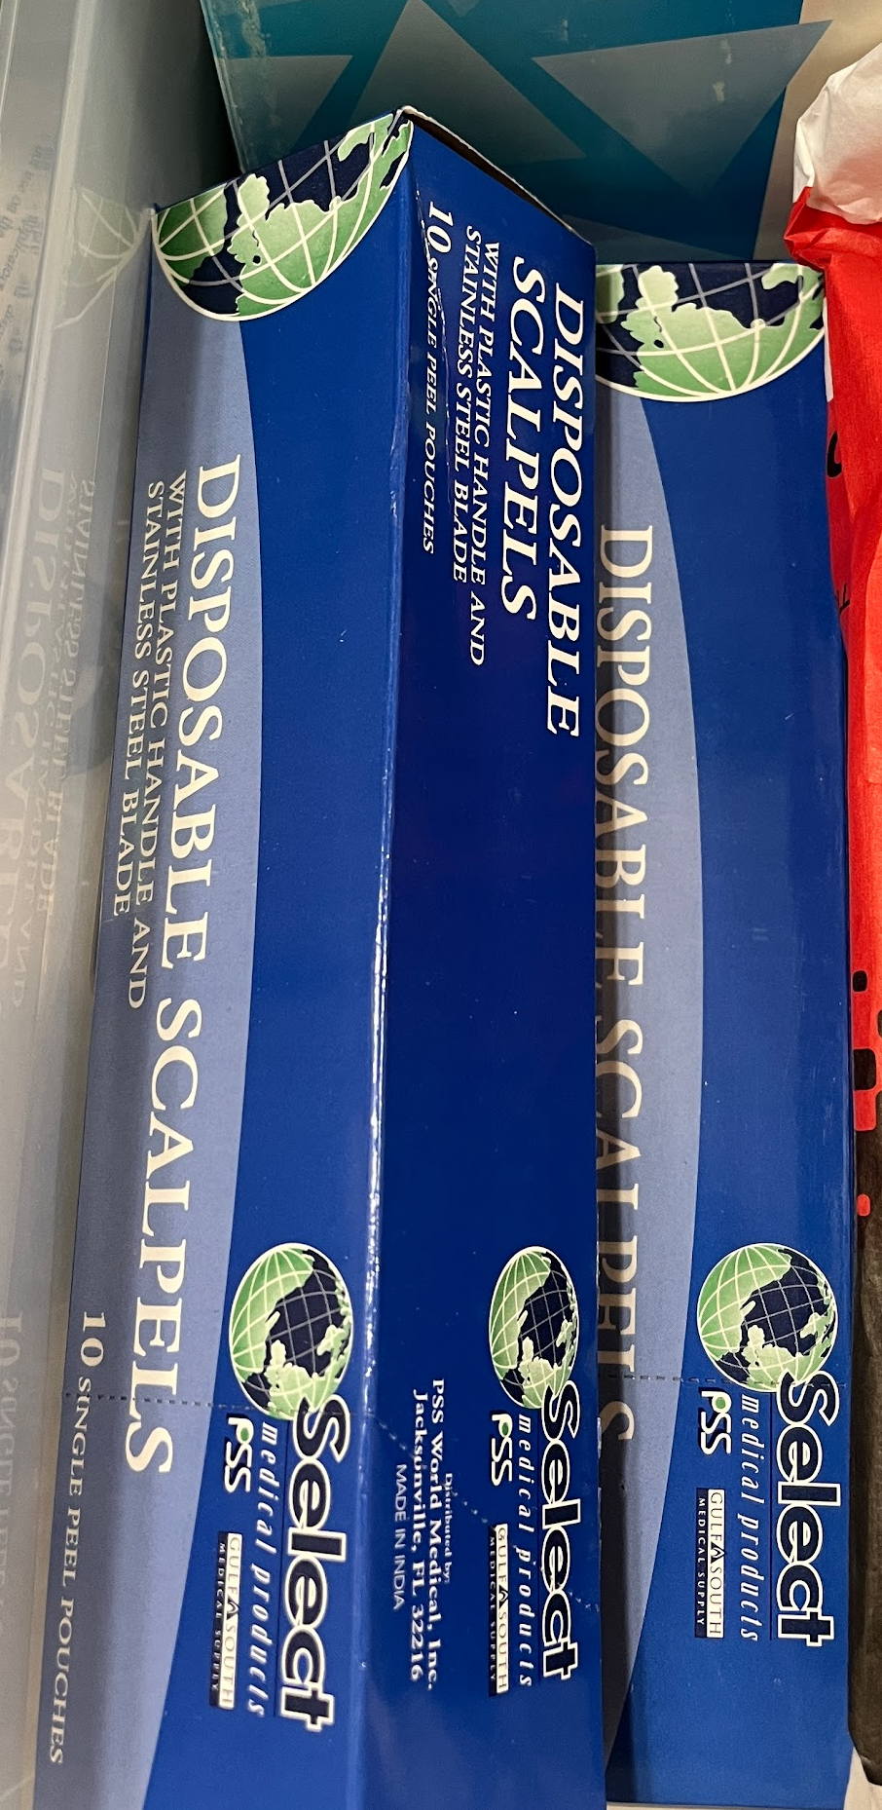  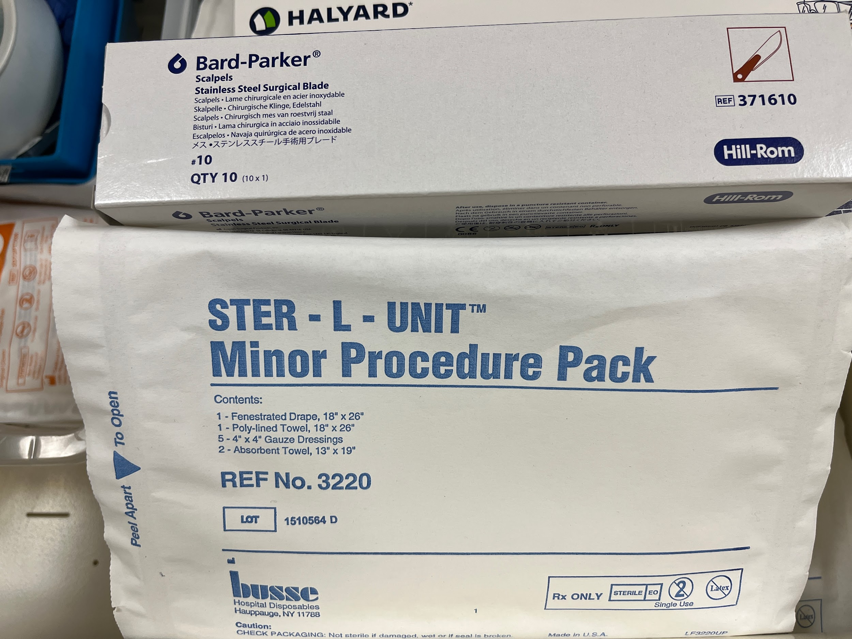
Sterile gloves  Found in Storage Room | 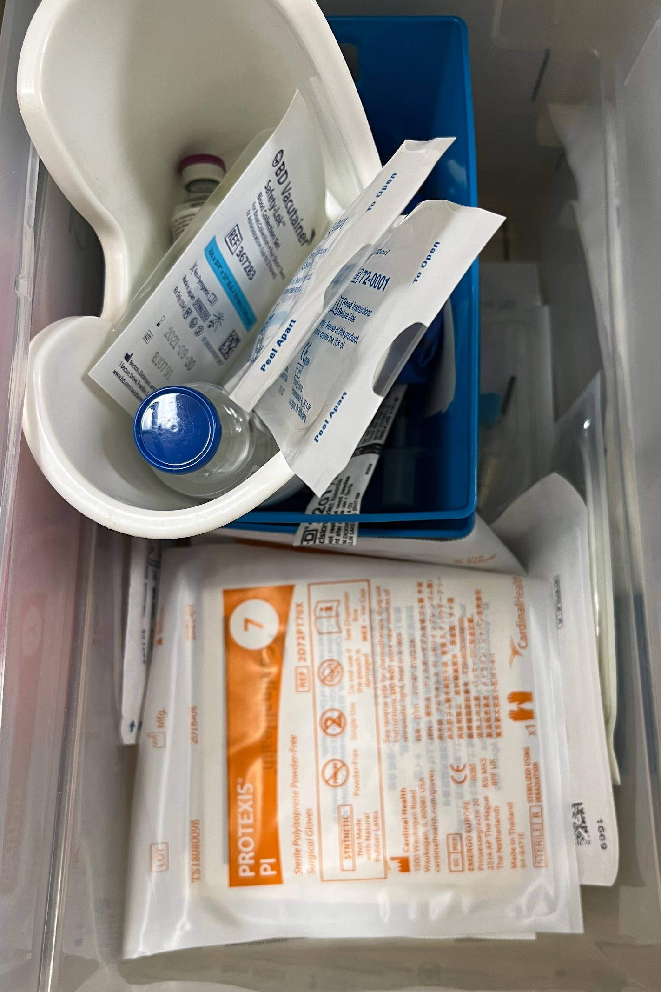
Specimen Container of Formalin  Do NOT use ThinPrep containers! They look similar but Thin Prep is for pap smears  The clinic supply is in the bin in the nursing station with the rest of our Gyn supplies.  It is also found in the yellow supply cart in Room 5-6 but only use if our supply is depleted. | 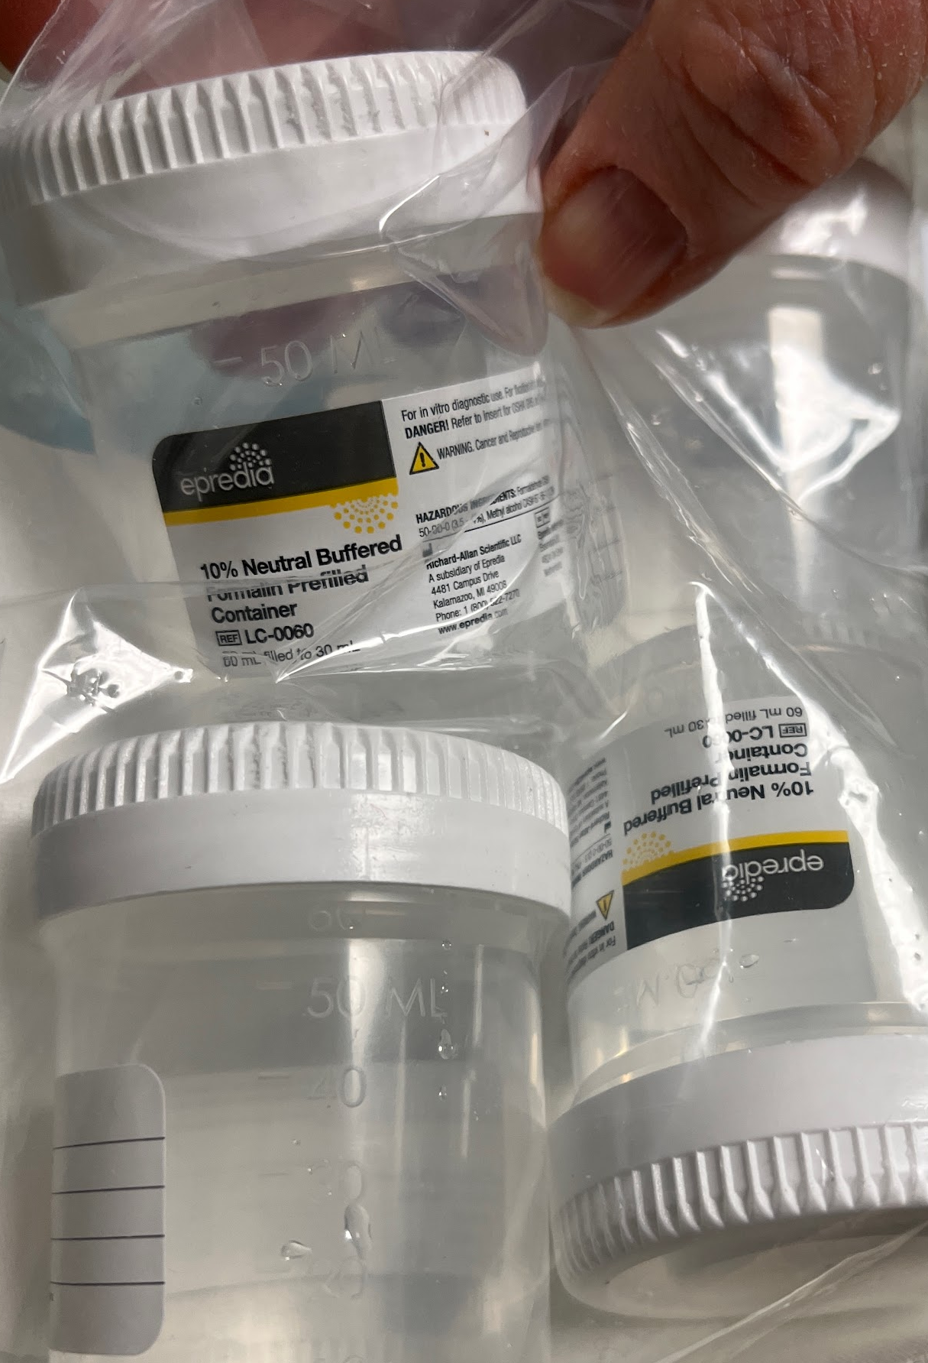
Alcohol wipes and Band-Aids can be found in the box for Hemoglobin A1C testing
Other items include:
  - 3 CC Syringe
  - 1-inch 23-Gauge Needle
  - 4-0 Nylon Suture
  - Suture Kit
    - Includes drapes, gauze, and sterile tools (forceps, tissue scissors), all autoclaved prior to usage
  - Steri strips
  - Biohazard bag

FAQs
- Do we have pregnancy tests?
  - No. Patients must purchase an OTC pregnancy test or visit Henry Ford’s lab for a blood test
  - There is a Pregnancy Center in Lincoln Park that offers free testing
Call 313-386-4005 to get more info.
Email crisispregnancycenterlp@gmail.com to get more info.

- What is the process if patients request referrals for various services including vision, mental health, specialists, etc.?

- Admin will be responsible for processing requests for referrals to specialists and following up on them.
Please complete the consult form and include the patient name, specialty requested, and findings (reason for the consult). Add the specialty referral in the soap note under Plan. (Example: referral to Orthopedics for eval, etc.). The referral will be entered into the patient’s record by Admin.
- Referral information is available at the front desk for behavioral medicine, dental, and other resources for obtaining insurance, food, housing, utilities, etc.
- Findhelp.org is a referral organization that we participate with and any patient can access or we can do it for them.
- Calling 211 is a United Way organization to help in urgent situations.
- Good Rx is an app we use to find the lowest price on prescribed medications.
- Information about other free and charitable clinics may be found at fcomi.org

- Where do I find the key to the Henry Ford Wyandotte Hospital (HFWH) box, which stores the HFWH lab samples?

The key is pinned to the bulletin board in the Admin Office.

